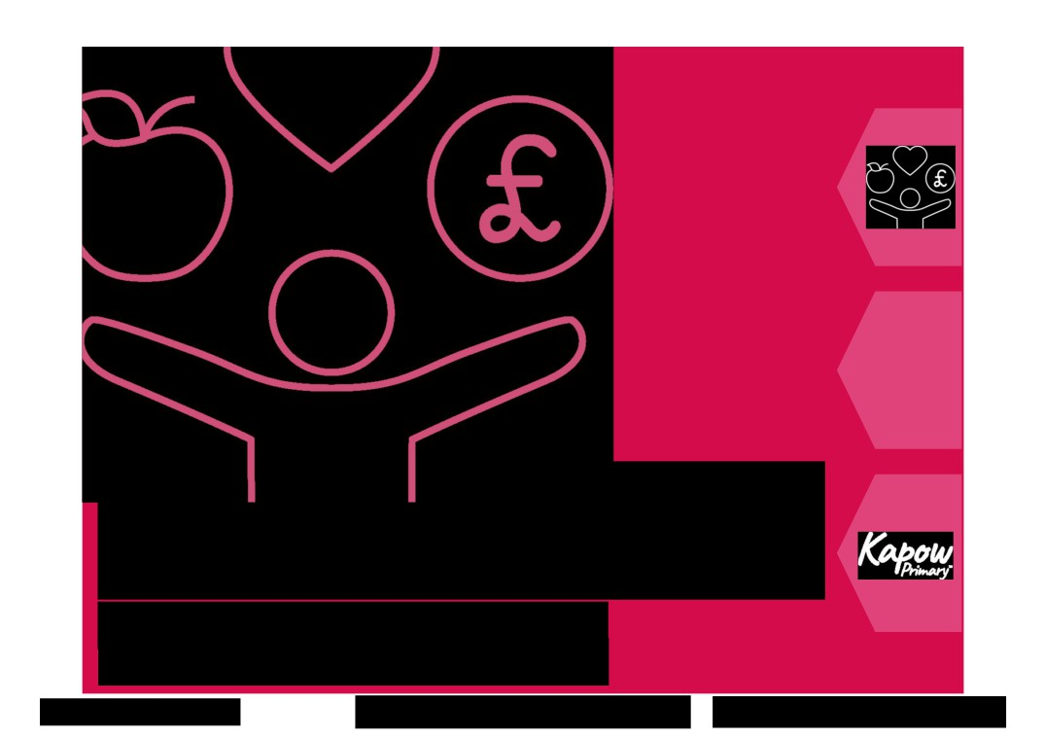

RSE & PSHE

Progression of knowledge and skills
Subject leader overview EYFS - Year 6
© Copyright Kapow Primary 2022
Standard progression of knowledge and skills
www.kapowprimary.com



Introduction

An overview of the skills and knowledge covered in each year group and strand across the units of lessons.

Please note that, although our EYFS: Reception lessons are categorised under Self-regulation, Building relationships and Managing self units to match the EYFS:Framework, we have included organised skills and knowledge statements under the key areas we use
throughout the rest of our scheme to more easily show progression between year groups.

This document was last updated on 04.04.24. Please check here for the most up to date version.
Copyright: While we encourage you to share this document within your school community, please ensure that it is only uploaded to your school website if it is password
protected.

Related resources:
If you are following our Long-term plan - condensed version, please see the corresponding Progression of skills and
knowledge - condensed.
If you are following our mixed-age curriculum for RSE & PSHE, please see the Progression of skills and knowledge -
mixed-age.
© Copyright Kapow Primary 2022
Standard progression of knowledge and skills
www.kapowprimary.com

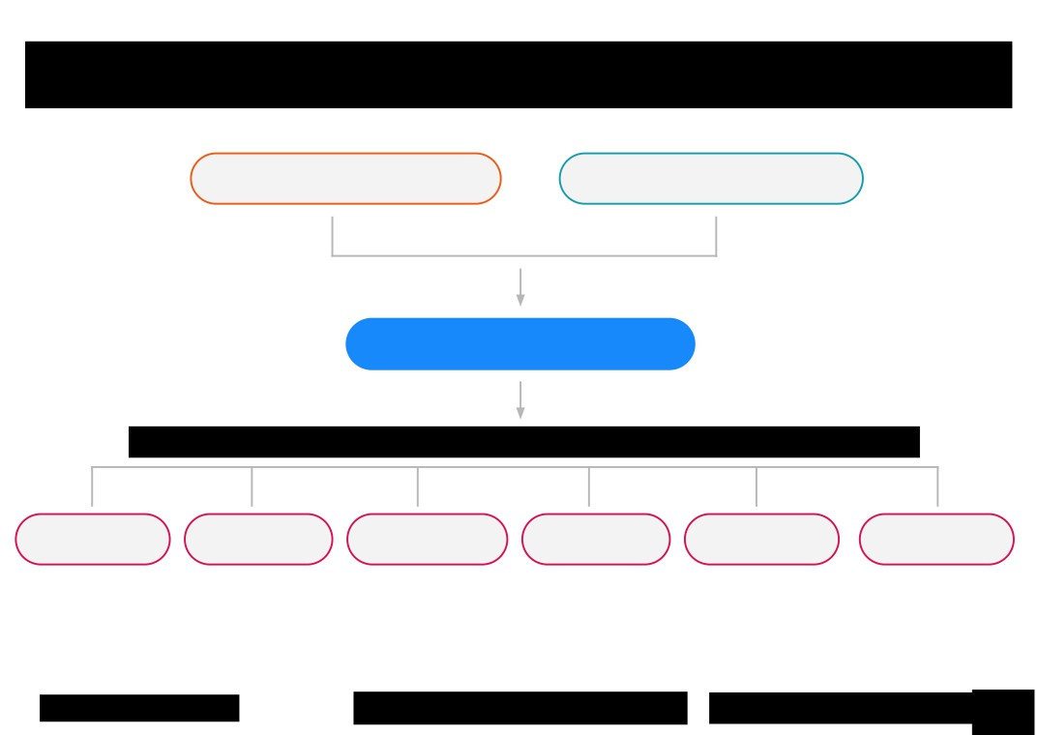

How is Kapow Primary’s RSE & PSHE scheme of work organised?

RSE Statutory guidance
(and non-statutory sex education)

PSHE Association Programme of Study

Kapow Primary scheme of work

Kapow Primary key areas

Family and Health and Safety and the
relationships wellbeing changing body

Citizenship

Economic well Identity
being (Y6 only)

© Copyright Kapow Primary 2022
Standard progression of knowledge and skills
www.kapowprimary.
3

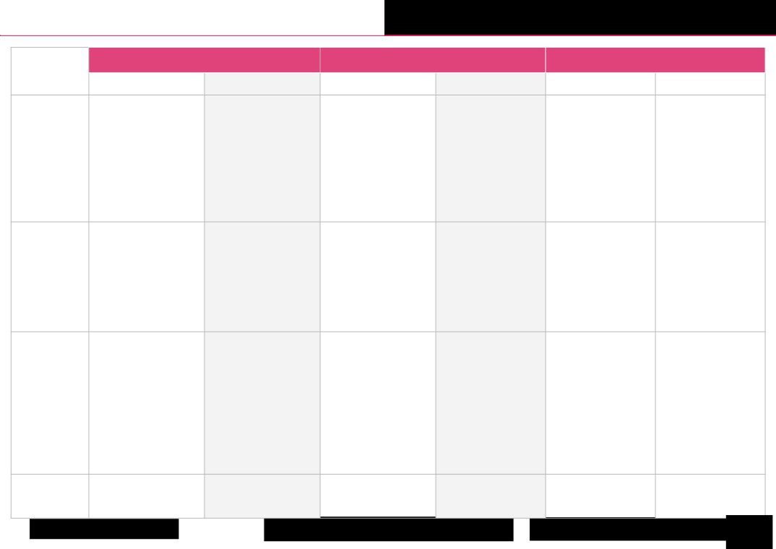
Progression of skills and knowledge Families and relationships

EYFS (Reception) Year 1 Year 2
Sub-strand
Skills Knowledge Skills Knowledge Skills Knowledge

Family
Learning how to talk about our families and discussing why we love them.

Talking about people that
hold a special place in my life.

To name and describe the Exploring how families are
different members of our different to each other.
families.

To understand that all
families are valuable and
special.
To understand that families look after us.

To know some words to
describe how people are
related (eg. aunty, cousin).

To know that some
information about me and my family is personal.

Understanding ways to To know that families can
show respect for different be made up of different
families. people.

Understanding that To know that families may
families offer love, care and be different to my family.
support.

Developing strategies to help To know that we share toys Exploring how friendship To understand some Understanding difficulties To know some problems
when sharing with others. so that everyone feels problems can be overcome. characteristics of a positive in friendships and which might happen in
involved and no one feels left friendship. discussing action that can friendships.
Exploring what makes a good out or upset. Exploring friendly be taken.
friend. behaviours. To understand that To understand that some
Friendships friendships can have problems in friendships
problems but that these might be more serious and
can be overcome. need addressing.

Thinking about what it To understand that different Recognising how other To know that it is called Learning how other people
means to be a valued person. people like different things. people show their feelings. stereotyping when people show their feelings and
think of things as being 'for how to respond to them.
Exploring the differences To understand that all people Identifying ways we can care boys' or 'for girls' only.
between us that make each are valuable. for others when they are sad. Exploring the conventions
person unique. of manners in different
Respectful To know that it is important Exploring the ability to situations.
relationships Considering the perspectives to help, listen and support successfully work with
and feelings of others. others when working as a different people.
team.
Learning to work as a
member of a team. To know that it is important
to tell the truth. Developing listening skills.

To understand some ways
people show their feelings.

To understand what good manners are.

To understand some
stereotypes related to jobs.

N/A N/A
Change and
loss

N/A N/A

Exploring how loss and To know that there are
change can affect us. ways we can remember
people or events.

© Copyright Kapow Primary 2022
Standard progression of knowledge and skills
www.kapowprimary.
4

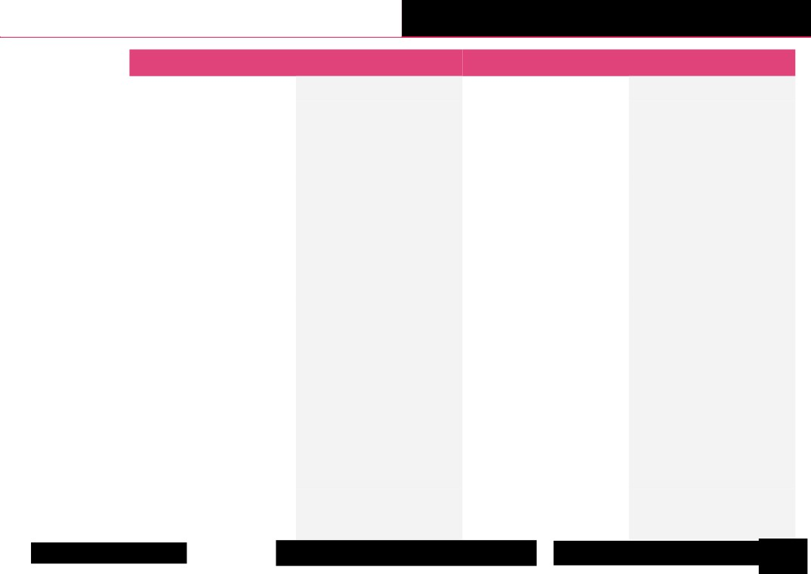
Progression of skills and knowledge Families and relationships

Sub-strand | Year 3 |  | Year 4
Sub-strand | Skills | Knowledge | Skills | Knowledge
Family | Learning that problems can occur in  families and that there is help available if  needed. | To know that I can talk to trusted adults or  services such as Childline if I experience  family problems. | Using respectful language to discuss  different families. | To know that families are varied in the  UK and across the world.
Friendships | Exploring ways to resolve friendship  problems.  Developing an understanding of the  impact of bullying and what to do if  bullying occurs. | To know that bullying can be physical or  verbal.  To know that bullying is repeated, not a  one off event.  To know that violence is never the right  way to solve a friendship problem | Exploring physical and emotional  boundaries in friendships. | To understand the different roles  related to bullying including victim,  bully and bystander.  To understand that everyone has the  right to decide what happens to their  body.
Respectful  relationships | Identifying who I can trust.  Learning about the effects of non verbal  communication.  Exploring the negative impact of  stereotyping. | To know that trust is being able to rely on  someone and it is an important part of  relationships.  To know the signs of a good listener.  To understand how to listen carefully and  why listening is important.  To understand that there are similarities  and differences between people.  To understand some stereotypes related  to age. | Exploring how my actions and  behaviour can affect other people. | To understand the courtesy and  manners which are expected in  different scenarios.  To understand some stereotypes  related to disability.
Change and loss | N/A | N/A | Discussing how to help someone who  has experienced a bereavement. | To know that bereavement describes  the feeling someone might have after  someone dies or another big change in  their lives.
© Copyright Kapow Primary 2022
Standard progression of knowledge and skills
www.kapowprimary.
5

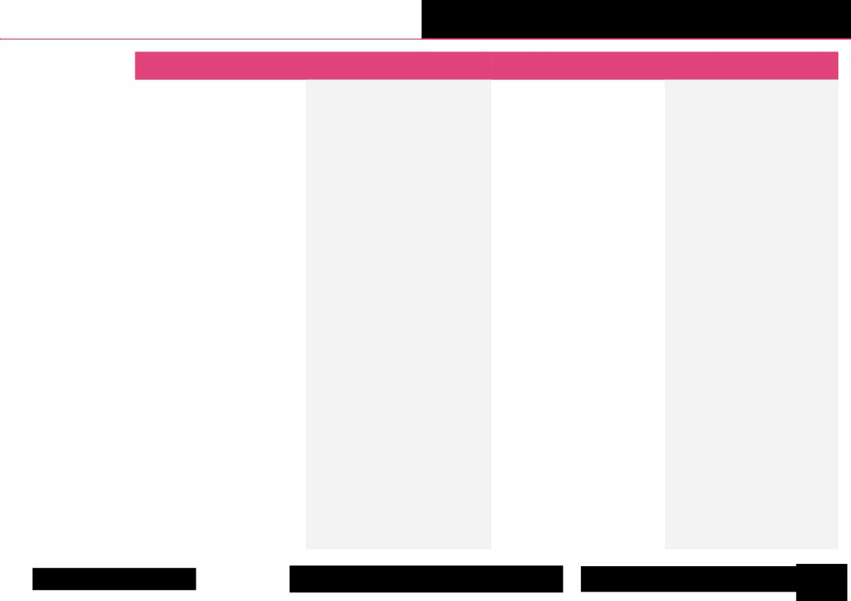
Progression of skills and knowledge Families and relationships

Sub-strand | Year 5 |  | Year 6
Sub-strand | Skills | Knowledge | Skills | Knowledge
Family | Identifying ways families might make  children feel unhappy or unsafe. | To know that marriage is a legal  commitment and is a choice people can  make.  To know that if I have a problem, I can call  ChildLine on 0800 1111. | N/A | N/A
Friendships | Exploring the impact that bullying  might have.  Exploring issues which might be  encountered in friendships and how  these might impact the friendship. | To know what attributes and skills make a  good friend.  To understand what might lead to  someone bullying others.  To know what action a bystander can take  when they see bullying. | Identifying ways to resolve conflict  through negotiation and compromise. | To know that a conflict is a  disagreement or argument and can  occur in friendships.  To understand the concepts of  negotiation and compromise.
Respectful  relationships | Exploring and questioning the  assumptions we make about people  based on how they look.  Exploring our positive attributes and  being proud of these (self-respect). | To understand that positive attributes are  the good qualities that someone has.  To know that stereotypes can be unfair,  negative and destructive.  To know that discrimination is the unfair  treatment of different groups of people,  especially on the grounds of race, age, sex,  or disability. | Discussing how and why respect is an  important part of relationships.  Identifying ways to challenge  stereotypes. | To understand what respect is.  To understand that everyone deserves  respect but respect can be lost.  To understand that stereotypes can  lead to bullying and discrimination.
Change and loss | N/A | N/A | Exploring the process of grief and  understanding that it is different for  different people. | To understand that loss and change can  cause a range of emotions.  To know that grief is the process people  go through when someone close to  them dies.
© Copyright Kapow Primary 2022
Standard progression of knowledge and skills
www.kapowprimary.
6

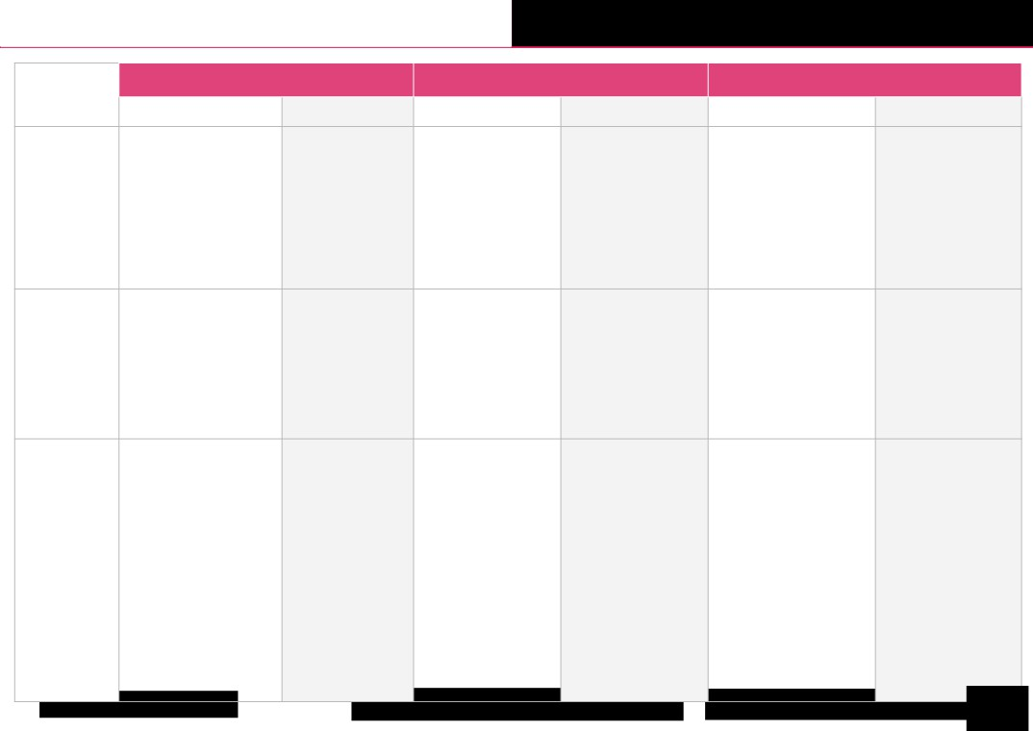
Progression of skills and knowledge Health and wellbeing

EYFS (Reception) Year 1 Year 2
Sub-strand
Skills Knowledge Skills Knowledge Skills Knowledge

Discussing ways that we can take care of ourselves.

Health and
prevention

To know that having a Learning how to wash my
naturally colourful diet hands properly. is one way to try and eat
healthily, Learning how to deal with
an allergic reaction.
To understand we can limit the spread of germs by
having good hand hygiene.

To know the five S's for sun safety: slip, slop, slap,
shade, sunglasses.

To know that certain foods
and other things can cause
allergic reactions in some
people.
Exploring the effect that food
and drink can have on my teeth.
To know that food and drinks with lots of sugar are bad for our teeth.

Exploring how exercise affects different parts of the body.

Physical
health and
wellbeing

To know that exercise Exploring positive sleep
means moving our body habits. and is important.
Exploring two different
To know that yoga can methods of relaxation:
help our bodies and progressive muscle
minds relax, relaxation and laughter.

Exploring health-related jobs and people who help look after our health.

To know that sleep helps Exploring some of the benefits
my body to repair itself, to of exercise on body and mind. grow and restores my
energy. Exploring some of the benefits
of a healthy balanced diet.

Suggesting how to improve an unbalanced meal.
Learning breathing exercises to aid relaxation.
To explain the importance
of exercise to stay healthy.

To understand the balance
of foods we need to keep
healthy.

To know that breathing techniques can be a useful strategy to relax.

Mental
wellbeing
Identifying how characters
within a story may be feeling.

Identifying and expressing my own feelings.
Exploring coping strategies to help regulate emotions.
Exploring different facial
expressions and identifying the
different feelings they can
represent.
Exploring ways to moderate behaviour, socially and
emotionally.

Coping with challenge when problem solving.

To name some different Identifying personal
feelings and emotions. strengths and qualities.

To know that I am a Identifying different ways
valuable individual. to manage feelings.

To know that facial
expressions can give us
clues as to how a person
is feeling.
To know that I can learn from my mistakes.
To know some
strategies to calm down.
To know that strengths are things we are good at.

To know that qualities
describe what we are like.

To know the words to
describe some positive and negative emotions.

Exploring strategies to manage different emotions.
Developing empathy.
Identifying personal goals and
how to work towards them.
Exploring the need for
perseverance and developing a growth mindset.
Developing an understanding of self respect.
To know that we can feel
more than one emotion at a
time.

To know that a growth
mindset means being
positive about challenges and finding ways to
overcome them.

© Copyright Kapow Primary 2022
Standard progression of knowledge and skills
www.kapowprimary.
7

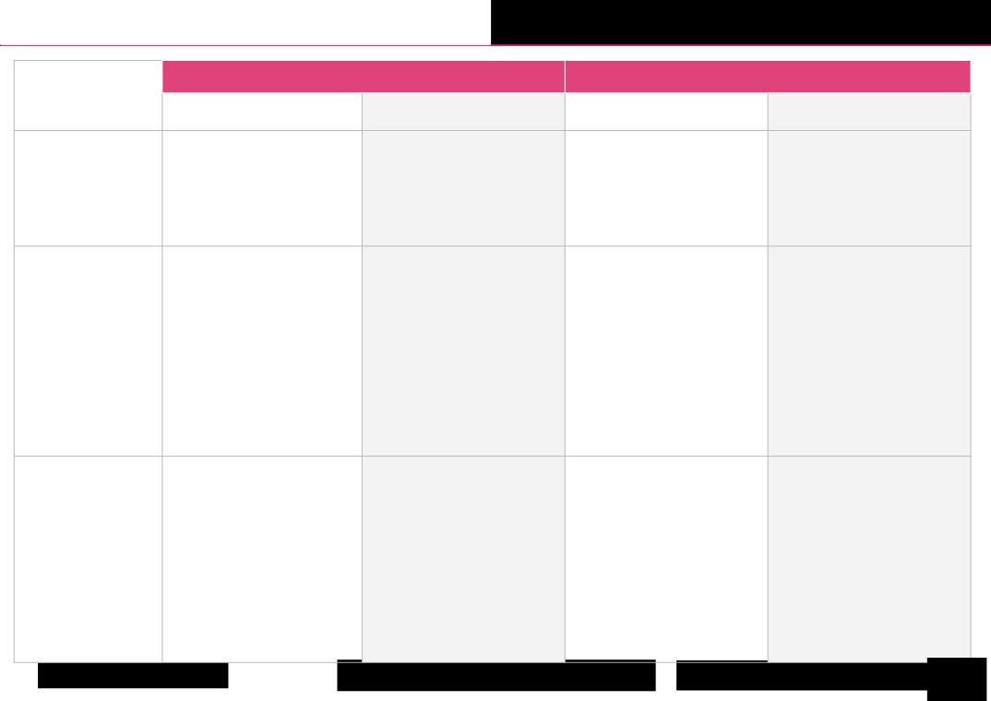
Progression of skills and knowledge Health and wellbeing

Year 3 Year 4
Sub-strand
Skills Knowledge Skills Knowledge

Discussing why it is important to look To understand ways to prevent tooth Developing independence in looking To know key facts about dental health.
after my teeth. decay. after my teeth.
Health and
prevention

Physical health and
wellbeing

Learning stretches which can be used for relaxation.
Developing the ability to plan for a healthy lifestyle with physical activity, a balanced diet and rest.

To understand the positive impact
relaxation can have on the body.
To know the different food groups and how much of each of them we should have to have a balanced diet.

Identifying what makes me feel calm and relaxed.

Learning visualisation as a tool to aid relaxation.

To know that visualisation means
creating an image in our heads.

Exploring my own identity through the groups I belong to.

Identifying my strengths and exploring how I use them to help others.

Being able to breakdown a problem
Mental wellbeing into smaller parts to overcome it.

To understand the importance of belonging.

To understand what being lonely means and that it is not the same as being
alone.

To understand what a problem or barrier is and that these can be overcome.

Exploring how my skills can be used to undertake certain jobs.

Explore ways we can make ourselves feel happy or happier.

Developing the ability to appreciate the emotions of others in different
situations.

Learning to take responsibility for my emotions by knowing that I can control some things but not others.
Developing a growth mindset.

To know that different job roles need different skills and so some roles may suit me more than others.
To know that it is normal to experience a range of emotions.

To know that mental health refers to
our emotional wellbeing, rather than
physical.

To understand that mistakes can help us to learn.
To know who can help if we are worried
about our own or other people's mental
health.

© Copyright Kapow Primary 2022
Standard progression of knowledge and skills
www.kapowprimary.
8

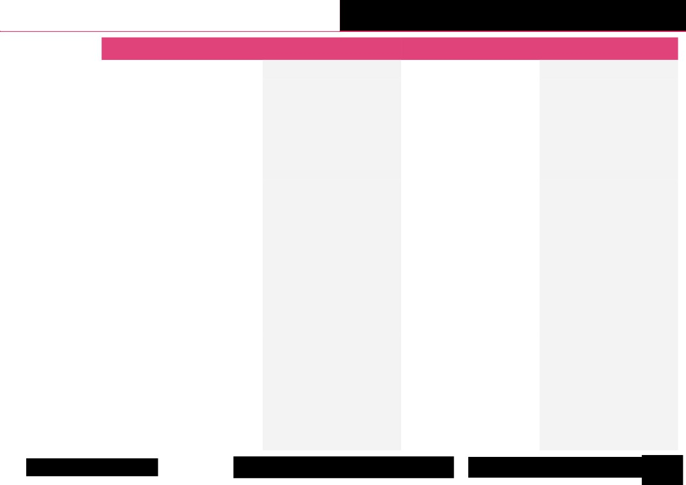
Progression of skills and knowledge Health and wellbeing

Sub-strand | Year 5 |  | Year 6
Sub-strand | Skills | Knowledge | Skills | Knowledge
Health and  prevention | Developing independence for protecting  myself in the sun. | To understand the risks of sun  exposure. | Considering ways to prevent illness.  Identifying some actions to take if I am  worried about my health or my friends’  health. | To understand that vaccinations can  give us protection against disease.  To know that changes in the body could  be possible signs of illness.
Physical health  and wellbeing | Understanding the relationship between  stress and relaxation.  Considering calories and food groups to plan  healthy meals.  Developing greater responsibility for ensuring  good quality sleep. | To know that relaxation stretches can  help us to relax and de-stress.  To know that calories are the unit that  we use to measure the amount of  energy certain foods give us.  To know that what we do before bed  can affect our sleep quality. | Identifying a range of relaxation  strategies and situations in which they  would be useful.  Exploring ways to maintain good  habits.  Setting achievable goals for a healthy  lifestyle. | To understand that a number of factors  contribute to my physical health (diet,  exercise, rest/relaxation, dental  health).  To know that a habit is a behaviour that  we often do without thinking and that  we can have good and bad habits.
Mental  wellbeing | Taking responsibility for my own feelings. | To understand what can cause stress.  To understand that failure is an  important part of success. | Exploring my personal qualities and  how to build on them.  Developing strategies for being  resilient in challenging situations. | To understand that a number of factors  contribute to my mental health (Diet,  exercise, rest/relaxation).  To know the effects technology can  have on mental health.
© Copyright Kapow Primary 2022
Standard progression of knowledge and skills
www.kapowprimary.
9

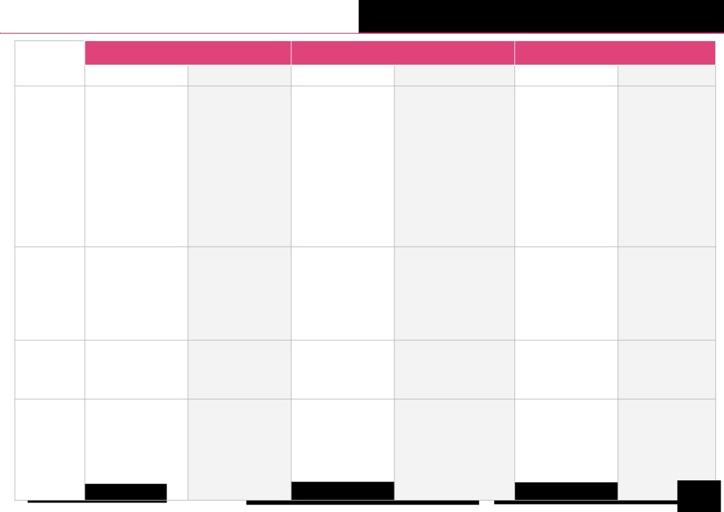
Progression of skills and knowledge Safety and the changing body

EYFS (Reception) Year 1 Year 2
Sub-strand
Skills Knowledge Skills Knowledge Skills Knowledge

Considering why it is
important to follow rules.

Exploring what it means
to be a safe pedestrian.
Being safe
(including
online)
To know that some rules Practising what to do if I
are in place to keep us get lost.
safe.
Identifying hazards that
To know how to behave may be found at home. safely on the pavement
and when crossing roads Understanding people's
with an adult. roles within the local
community that help keep us safe.
To know that some types of physical contact are never appropriate.

To know what to do if I get lost.

To know that a hazard is something which could cause an accident or injury.
Discussing the concept of To know the PANTS rule.
privacy.
To know that I should
Exploring ways to stay tell an adult if I see
safe online. something which makes
me uncomfortable
Learning how to behave online. safely near the road and
when crossing the road. To understand the
difference between
secrets and surprises.
To know the rules for
crossing the road safely.

N/A N/A

Drugs,
alcohol and
tobacco

Learning what is and is not safe to put in or on our
bodies.

To know that some things are
unsafe to put onto or into my
body and to ask an adult if I am
not sure.

Exploring what people can To know that medicine
do to feel better when can help us when we are
they are ill. ill.

Learning how to be safe To understand that we
around medicines. should only take
medicines when a
trusted adult says we
can.

The N/A N/A
changing
adolescent
body

N/A N/A

N/A To know the names of
parts of my body
including private parts.

N/A N/A Practising making an To know that an emergency is a N/A N/A
emergency phone call. situation where someone is
badly hurt, very ill or a serious
accident has happened.
Basic first
aid To know that the emergency
services are the police, fire
service and the ambulance
service.
apow Primary 2022 ndard progression of knowl ww 10

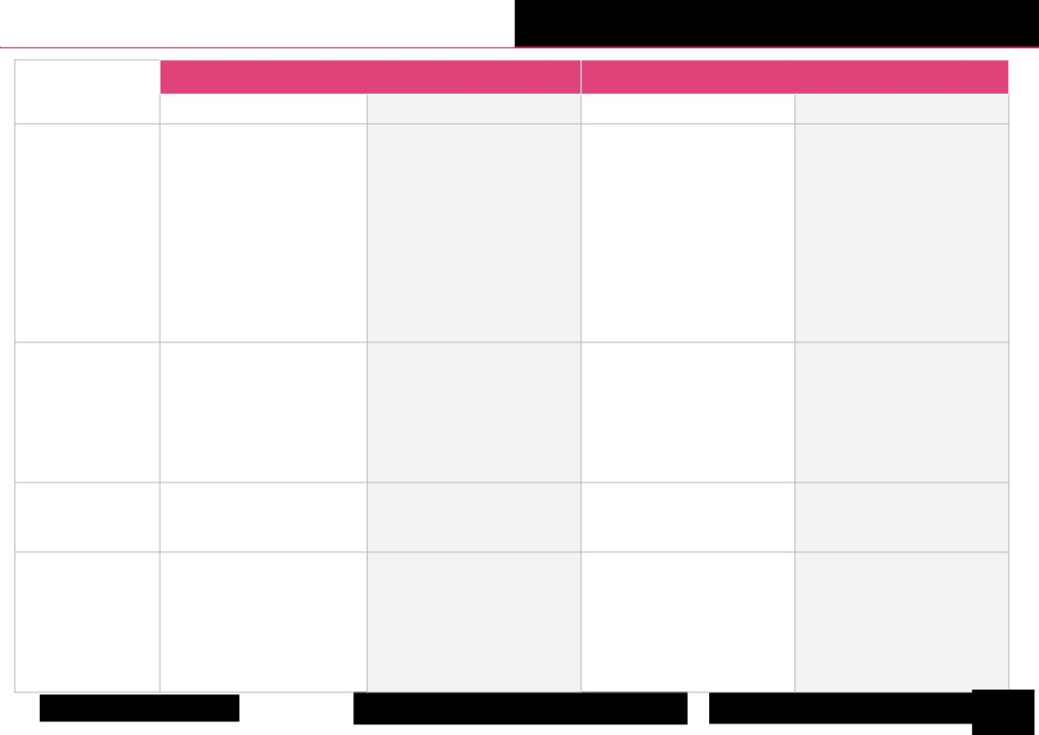
Progression of skills and knowledge Safety and the changing body

Year 3 Year 4
Sub-strand
Skills Knowledge Skills Knowledge

Exploring ways to respond to
cyberbullying or unkind behaviour
online.

Developing skills as a responsible digital citizen.
Being safe Identifying things people might do
(including online) near roads which are unsafe.
Beginning to recognise unsafe digital content.
To understand that cyberbullying is
bullying which takes place online.
To know the signs that an email might be fake.
To know the rules for being safe near
roads.
Discussing how to seek help if I need to.

Exploring what to do if an adult makes me feel uncomfortable.

Learning about the benefits and risks of sharing information online.
To understand that there are risks to sharing things online.
To know the difference between private and public.

Drugs, alcohol and
tobacco

Exploring that people and things can influence me and that I need to make the right decision for me.
Exploring choices and decisions that I can make.

To understand that other people can influence our choices.

Discussing the benefits of being a non-smoker.

To understand the risks associated with smoking tobacco.

N/A N/A
The changing
adolescent body

Discussing some physical and emotional changes during puberty.

To understand the physical changes to both male and female bodies as people grow from children to adults.

Learning what to do in a medical emergency, including calling the emergency services.
Basic first aid

To know that bites or stings can
sometimes cause an allergic reaction.

To know that it is important to maintain the safety of myself and others, before giving first aid.

Learning how to help someone who is having an asthma attack.

To know that asthma is a condition
which causes the airways to narrow.

© Copyright Kapow Primary 2022
Standard progression of knowledge and skills
www.kapowprimary.
11

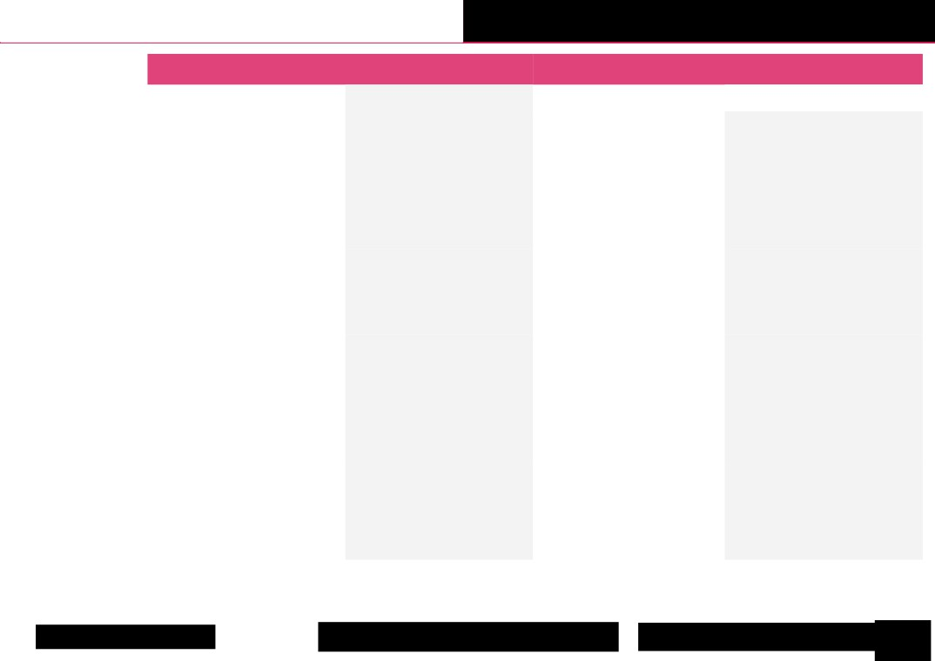
Progression of skills and knowledge Safety and the changing body

Sub-strand | Year 5 |  | Year 6
Sub-strand | Skills | Knowledge | Skills | Knowledge
Being safe  (including online) | Developing an understanding of how to  ensure relationships online are safe. | To know the steps to take before  sending a message online (using the  THINK mnemonic).  To know some of the possible risks  online. | Developing an understanding about the  reliability of online information.  Exploring online relationships including  dealing with problems. | To understand that online relationships  should be treated in the same way as face  to face relationships.  To know where to get help with online  problems.
Drugs, alcohol and  tobacco | Learning to make 'for' and 'against'  arguments to help with decision making. | To know some strategies I can use to  overcome pressure from others and  make my own decisions. | Discussing the reasons why adults may  or may not drink alcohol. | To understand the risks associated with  drinking alcohol.
The changing  adolescent body | Learning about the emotional changes  during puberty.  Identifying reliable sources of help with  puberty. | To understand the process of the  menstrual cycle.  To know the names of the external  sexual parts of the body and the  internal reproductive organs.  To know that puberty happens at  different ages for different people. | Discussing problems which might be  encountered during puberty and using  knowledge to help. | To understand how a baby is conceived  and develops.
Basic first aid | Learning about how to help someone  who is bleeding. | To know how to assess a casualty's  condition. | Learning how to help someone who is  choking.  Placing an unresponsive patient into  the recovery position. | To know how to conduct a primary  survey (using DRSABC).
© Copyright Kapow Primary 2022
Standard progression of knowledge and skills
www.kapowprimary.
12

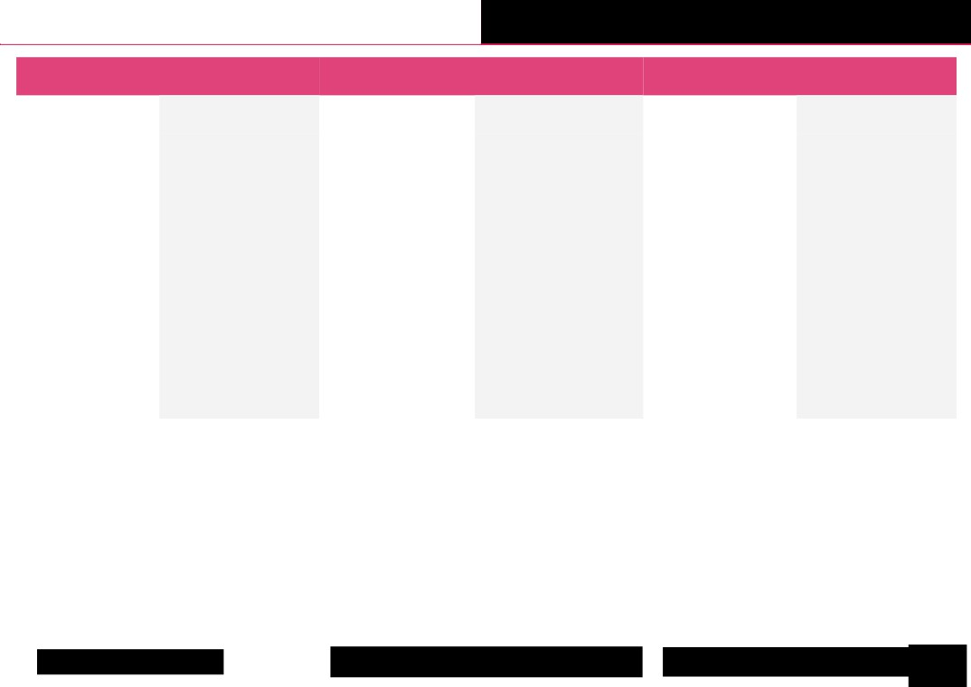
Progression of skills and knowledge Citizenship

EYFS (Reception) |  | Year 1 |  | Year 2
Skills | Knowledge | Skills | Knowledge | Skills | Knowledge
Beginning to understand  why rules are important in  school. | To know that we have rules to  keep everything fair, safe and  enjoyable for everyone.  To understand that we all have  similarities and differences and  that make us special.  To know that we all have  different beliefs and celebrate  special times in different ways. | Recognising why rules are  necessary and the  consequences of not  following rules.  Discussing how to meet the  needs of different pets.  Exploring the differences  between people.  Recognising the groups that  we belong to. | To know the rules in school.  To know that different pets have  different needs.  To understand the needs of  younger children and that these  change over time.  To know that voting is a fair way  to make a decision.  To understand that people are all  different and that this is a good  thing. | Explaining why rules are in  place in different settings.  Identifying positives and  negatives about the school  environment.  Learning how to discuss  issues of concern to me.  Recognising the importance  of looking after the school  environment.  Identifying ways to help look  after the school environment.  Recognising the contribution  people make to the local  community. | To know some of the different  places where rules apply.  To know that some rules are  made to be followed by  everyone and are known as  'laws'.  To know some of the jobs  people do to look after the  environment in school and the  local community.  To understand how democracy  works in school through the  school council.  To understand that different  groups of people make  different contributions to the  community.
© Copyright Kapow Primary 2022
Standard progression of knowledge and skills
www.kapowprimary.
13

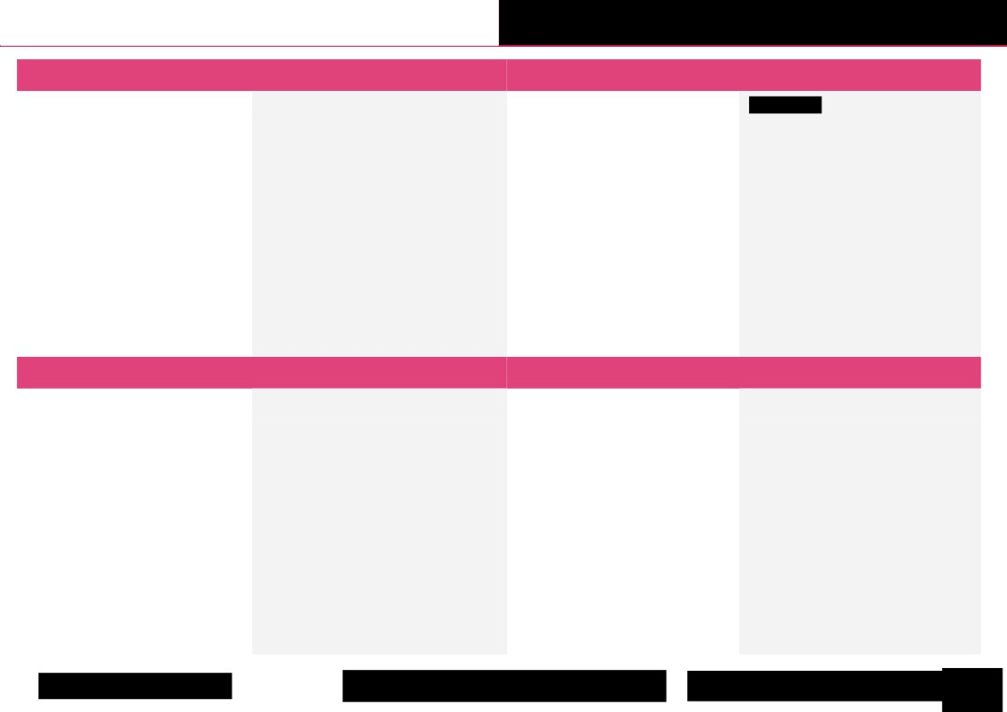
Progression of skills and knowledge Citizenship

Year 3 |  | Year 4
Skills | Knowledge | Skills | Knowledge
Exploring how children's rights help them and  other children.  Considering the responsibilities that adults  and children have to maintain children's  rights.  Discussing ways we can make a difference to  recycling rates at home/school.  Identifying local community groups and  discussing how these support the community. | To understand the UN Convention on the Rights  of the Child.  To understand how recycling can have a positive  impact on the environment.  To know that the local council is responsible for  looking after the local area.  To know that elections are held where adults can  vote for local councillors.  To understand some of the consequences of  breaking rules.  To understand the role of charities in the  community. | Discussing how we can help to protect  human rights.  Identifying ways items can be reused.  Explaining why reusing items is of benefit to  the environment.  Identifying the benefits different groups  bring to the local community.  Discussing the positives diversity brings to a  community. | To know that human rights are specific rights  that apply to all people.  To know some of the people who protect our  human rights such as police, judges and  politicians.  To know that reusing items is of benefit to the  environment.  To understand that councillors have to balance  looking after local residents and the needs of  the council.  To know that there are a number of groups  which make up the local community.
Year 5 |  | Year 6
Skills | Knowledge | Skills | Knowledge
Explaining why reducing the use of materials  is positive for the environment.  Discussing how rights and responsibilities  link.  Exploring the right to a freedom of  expression.  Identifying the contribution people make to  the community and how this is recognised.  Developing an understanding of how  parliament and Government work.  Identifying ways people can bring about  change in society. | To know what happens when someone breaks the  law.  To understand the waste hierarchy.  To know that parliament is made up of the House  of Commons, the House of Lords and the  Monarch.  To know that parliament is where MPs debate  issues, propose laws, amend existing laws and  challenge the government’s work.  To know that a pressure group is a group of people  who feel very strongly about an issue and want to  see something change. | Learning about environmental issues relating  to food.  Discussing how education and other human  rights protect us.  Identifying causes which are important to us.  Discussing how people can influence what  happens in parliament.  Discussing ways to challenge prejudice and  discrimination.  Identifying appropriate ways to share views  and ideas with others. | To know that education is an important human  right.  To know that our food choices can affect the  environment.  To know that the prime minister appoints  'ministers' who have responsibility for different  areas, such as healthcare and education.  To know that prejudice is making assumptions  about someone based on certain information.  To know that discrimination is treating  someone differently because of certain factors.
© Copyright Kapow Primary 2022
Standard progression of knowledge and skills
www.kapowprimary.
14

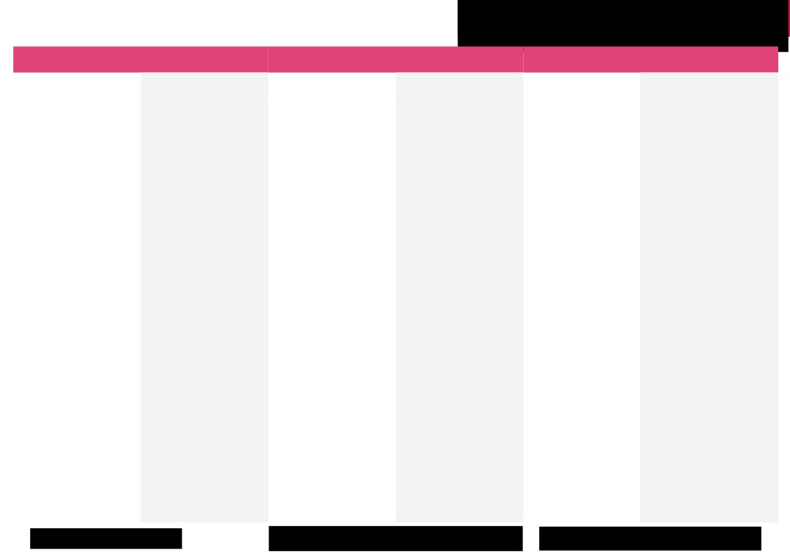
Progression of skills and knowledge
Economic wellbeing

Year 1 |  | Year 2 |  | Year 3
Skills | Knowledge | Skills | Knowledge | Skills | Knowledge
Exploring how money is used by  people.  Discussing how to keep money  safe.  Discussing what to do if we find  money.  Exploring choices people make  about money.  Developing an understanding of  how banks work.  Listening to descriptions of  professions.  Thinking about questions they  would like to ask others about  their job.  Describing what different  people do in their jobs. | To know that people use money  to buy things, including things  they need and things they want.  To know that coins and notes  are types of money and have  different values.  To know that notes are higher in  value than coins.  To know that it is wrong to steal  money.  To know that money is valuable  and needs to be looked after.  To know that money should be  stored in a safe place to keep it  secure and should not be  displayed in public places.  To know that they should not  show or give money to  strangers.  To know that they can ask  adults they know and trust  about money and where to  store it safely.  To know that banks are places  where we can store our money.  To know adults have jobs to help  others and to earn money.  To know that skills are things  that we can do well and that  everyone has different skills.  To know that different jobs  need different skills. | Explaining adult money sources.  Identifying whether something  is a want or need.  Comparing and contrasting  'wants' and 'needs'.  Identifying the main features of  bank account cards.  Exploring personal skills and  talents.  Exploring the reasons why  people choose certain jobs.  Identifying some ways to make  an environment inclusive and  fair.  Reflecting on the importance of  individuality and diversity. | To know that many adults earn  money by having a job.  To know some basic needs for  survival, such as food, water and  shelter.  To know that a bank account is  like a special place in a bank that  keeps money safe until it is  needed.  To know that a bank account  card is like a special key that  unlocks a bank account to  access the money inside.  To know that saving money is  when we keep some money and  don’t spend it straight away.  To know that it is important for  workplaces to include a variety  of people to bring different  viewpoints and skills. | Considering pros and cons of  payment methods.  Contemplating budgeting  benefits.  Planning and calculating  within a budget.  Discussing attitudes and  feelings about money.  Developing empathy in  financial situations.  Handling negative financial  emotions.  Making ethical spending  decisions.  Assessing impact of spending  choices.  Reflecting on future job  based on goals.  Challenging and  understanding workplace  stereotypes.  Ranking factors influencing  job choices. | To know that we can pay for things  using cash, a debit card, a credit  card, online banking, and digital  wallets.  To know that spending should be  based on necessity, importance,  and available budget.  To know that budgeting is planning  how to spend and save the money  that you have available.  To know that money can cause us  to have positive and negative  feelings.  To know how we spend money can  affect other people and the  environment, like buying  environmentally friendly products  to help protect the planet.  To know that different jobs  contribute to our society in  different ways.  To know that stereotypes are  oversimplified ideas about what  jobs are suitable for people based  on gender, race, or other  characteristics.  To know that it is important to  consider what they are good at and  enjoy doing when choosing future  careers.  To know that they can aim for any  career they are interested in and  passionate about, regardless of  stereotypes or other people's  expectations.
© Copyright Kapow Primary 2022
Standard progression of knowledge and skills
www.kapowprimary.com

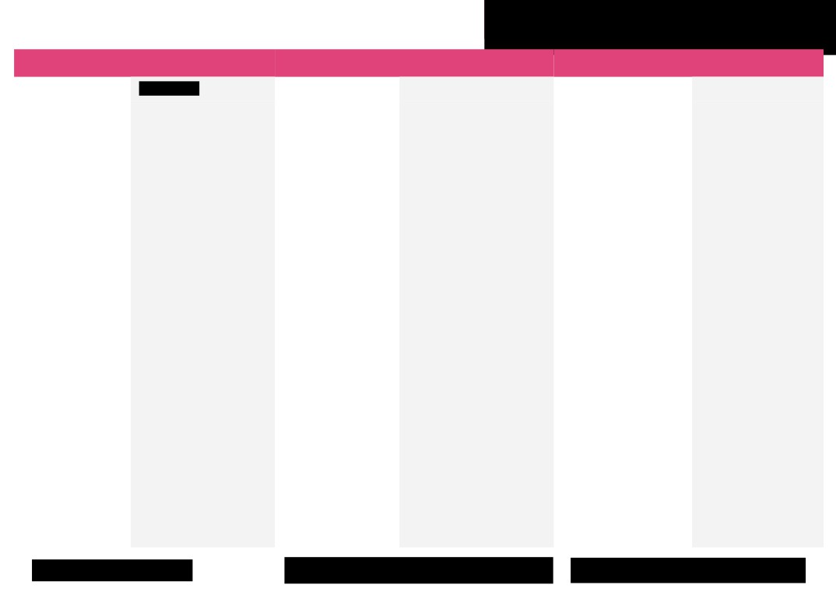
Progression of skills and knowledge
Economic wellbeing

Year 4 |  | Year 5 |  | Year 6
Skills | Knowledge | Skills | Knowledge | Skills | Knowledge
Recognising value for  money.  Understanding differing  opinions on spending.  Recognising how to track  money spent and saved.  Understanding reasons for  using a bank.  Exploring how to  safeguard money  effectively.  Identifying influences on  job choices.  Understanding careers can  change.  Challenging workplace  stereotypes. | To know that getting value for  money involves considering the  cost, usefulness and quality of  items.  To know that purchases can be  influenced by needs, wants, peer  pressure, and advertising.  To know that people often earn  interest when they keep savings in  a bank account.  To know that earning interest is  when the bank gives you some  extra money as a reward for  keeping your money with them.  To know that people often change  jobs or careers multiple times in  their lives.  To know that stereotypes can be  made on age, gender, culture,  ability and interest and hobbies. | Discussing money risks and  management.  Making and prioritising  budgets.  Discussing money's role in  career choices.  Assessing loan and  borrowing responsibilities  and suitability.  Implementing money  safeguarding strategies.  Navigating emotional  implications in financial  situations.  Seeking guidance for  financial dilemmas.  Integrating factors to inform  career decisions. | To know that being ‘in debt’ or  ‘having debt’ means that you have  spent more money than you have and  owe money to others or the bank.  To know the difference between  money earned (income) and money  spent (expenditure).  To know that borrowing money, like  loans or credit, involves the  responsibility to pay it back with  interest.  To know that when a bank or  someone lends you money, they may  ask you to pay back more than what  you borrowed. The extra amount is  the interest, which is like a fee for  using someone else's money.  To know that they should be cautious  about sharing financial information.  To know that money can cause a  range of emotions, from stress and  anxiety when finances are tight, to  happiness and excitement when they  can afford something they want.  To know that their educational  choices and personal interests can  play a significant role in determining  their future career options and  opportunities.  To know that it is important to  challenge work-related stereotypes  to create a more inclusive and fair  work environment. | Developing emotional  intelligence related to financial  matters.  Applying coping strategies for  managing financial emotions.  Assessing risks in both physical  and digital financial  environments.  Implementing safeguarding  measures for money in  real-world scenarios.  Adapting to financial changes  associated with transitioning to  secondary school.  Preparing personally for  financial and career changes in  secondary school.  Identifying different forms of  gambling and understanding  their risks.  Applying responsible gambling  attitudes in real-world  situations.  Recognising various workplace  environments and their  characteristics.  Identifying career options in  multiple sectors.  Evaluating the suitability of  different career paths.  Aligning career options with  personal interests and strengths. | To know that our emotions can  be linked to money.  To know an online scam is  when someone uses the  internet to trick or deceive  people into giving away their  money or personal  information.  To know that a secure  password should have a  combination of letters,  numbers and special symbols  and be kept secret from others.  To know that at secondary  school they may have to  manage different types of  expenses like lunches, travel  costs, school materials, and  social activities.  To know that gambling or  betting is paying to play a game  where you don’t know if you  will win more money or lose  your money.  To know that gambling can  cause people to lose a lot of  money and can be very  addictive.  To know that a career route is  the path you take to have a  particular career and the  qualifications and experience  you have to gain along the way.
© Copyright Kapow Primary 2022
Standard progression of knowledge and skills
www.kapowprimary.com

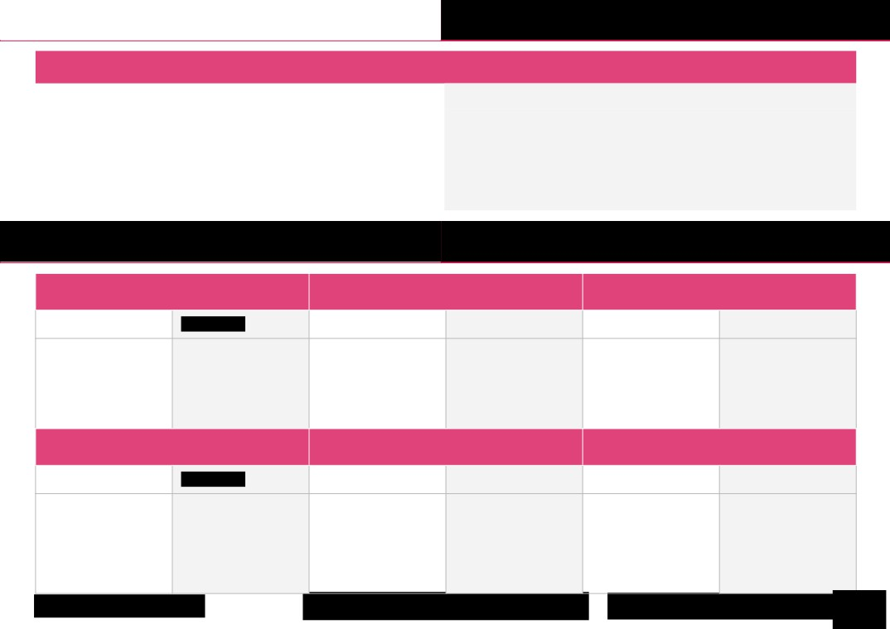
Progression of skills and knowledge Identity

Year 6 only
Skills | Knowledge
Discussing the factors that make our 'identity'.  Recognising the difference between how we see ourselves and how others see us.  Exploring how the media might influence our identity. | To know that identity is is the way we see ourselves and also how other people see us.
Progression of skills and knowledge Transition

Year 1 Year 2 Year 3

Skills Knowledge Skills Knowledge Skills Knowledge

Recognising our own To understand that changes Identifying people who can To understand that change is Learning strategies to deal To understand that change
strengths. can be both positive and help us when we are worried part of life. with change. often brings about more
negative. about changes. opportunities and
responsibilities.

Year 4 Year 5 Year 6

Skills Knowledge Skills Knowledge Skills Knowledge

Recognising our own To know that setting goals Recognising own skills and To understand the skills Exploring a greater range of To know that a big change
achievements. can help us to achieve what how these can be developed. needed for roles in school. strategies to deal with can bring opportunities but
we want. feelings associated with also worries.
Being able to set goals. change.
© Copyright Kapow Primary 2022
Standard progression of knowledge and skills
www.kapowprimary.
17


Version history

This page shows recent updates that have been made to this document.

Date | Update
26.07.22 | Knowledge statement removed on p.12 to reflect  changes to lessons in Identity unit.
31.01.23 | Addition of EYFS: Reception statements.
15.01.24 | Updated the Economic wellbeing knowledge and skills  statements (p. 15-16) to reflect the refreshed units on  the website.
04.04.24 | Updated colouring to match other subjects  (Knowledge- grey, skills-white).
© Copyright Kapow Primary 2022
Standard progression of knowledge and skills
www.kapowprimary.c
18

