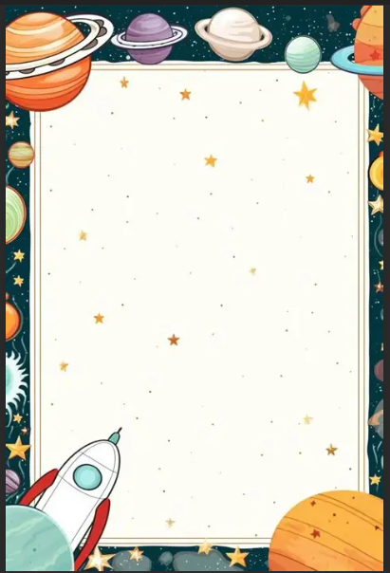

Stargazing Evening

As part of world space week, Tattingstone will be holding a stargazing evening

Children will have fun activities to complete

Hot chocolate

And toasting marshmallows

If you have binoculars, please bring these.

Starts at 5.45pm

£6.50