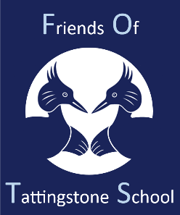

Friends of Tattingstone Primary School (FOTS)

Many thanks to those who attended our AGM meeting on Friday 15th November. We would like to welcome Amber Scott as the new Chair of FoTS. It was a very productive meeting with events in the diary for the 2nd part of this term. So far this term FoTS have contributed to the Kentwell Hall trip and held the half term disco which is always great fun. We have also organised the Halloween pumpkin competition; the children said they had fun creating and carving their pumpkins.

Coming up, we have Stars in our School. We will be holding a presentation for our support staff on Monday 21st November to show our gratitude for their help and support for the school, we are inviting parents and children to get involved by sending thank you messages and any donations would be appreciated.

Christmas Film Night will be held on Monday 16th December.

We will be holding 3 dress down days in exchange for items for the Christmas Fair. Children are welcome to come to school without school uniform on Friday 6th, Friday 13th and Monday 16th December in exchange for bottles, chocolate or items for the raffle. The Christmas Fair will be held on Friday 20th December at the school after the Nativity. As the children had so much fun with the pumpkin competition, we will be running a Christmas Stocking competition. We will send out more information about these events shortly.

Our next FoTS meeting will be held on Friday 17th January 2025 at 2.30pm in Wings. We shall look forward to seeing you all for a hot drink and cake, while brainstorming more events.

From the FOTS team,

Chair: Amber Scott, Treasurer: Michelle Dearsley, Secretary: Nadine Bartlett