
Tattingstone Church of England V.C. Primary School
Church Road, Tattingstone, Ipswich, Suffolk, IP9 2NA
Telephone: 01473 328488
Email: admin@tattingstone.suffolk.sch.uk
www.tattingstonecevcpschool.co.uk
Headteacher: Mrs Beverley Derrett
BEd-BSc-MA-NPQH-NPQEL

Turning Small Wonders into Shining Lights
__________________________________________________________________________________________

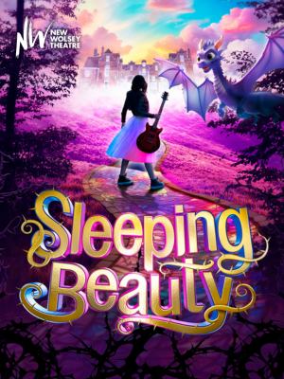
Monday 2nd December, 2024

Dear Parents,

We have booked a whole school trip to see the matinee performance of the pantomime ‘Sleeping Beauty’ at the New Wolsey Theatre on Wednesday 8th January, 2025.

Since making our booking, the start time of the performance has been changed. It now starts at 12 noon therefore all children will need to bring a packed lunch. Pupils in Years 1 and 6 will be taken by coach to The New Wolsey Theatre from school. Pupils in Years 2 -5 will be at Fore Street Swimming Pool in the morning so the coach will take them from the pool to the theatre rather than coming back to school.

The performance should finish at approximately 2.15pm and therefore we ask that you arrange to be at the theatre to pick your child/ren up at 2.15pm please. We will bring the children out to the front of the theatre at the end of the performance; please wait until the children are brought to the front of the theatre before taking your child.

FoTS have kindly agreed to pay for the cost of the coach for Years 1 and 6. There are no additional coach costs for Year 2-5. Therefore, we just require a contribution of £13.00 per pupil from parents to cover the cost of the theatre ticket. If you wish to apply for remittance, please make an appointment to speak to me. Pupils in receipt of Pupil Premium funding are not exempt from paying for school trips.

Please complete the consent slip and pay via ParentMail.

Yours sincerely

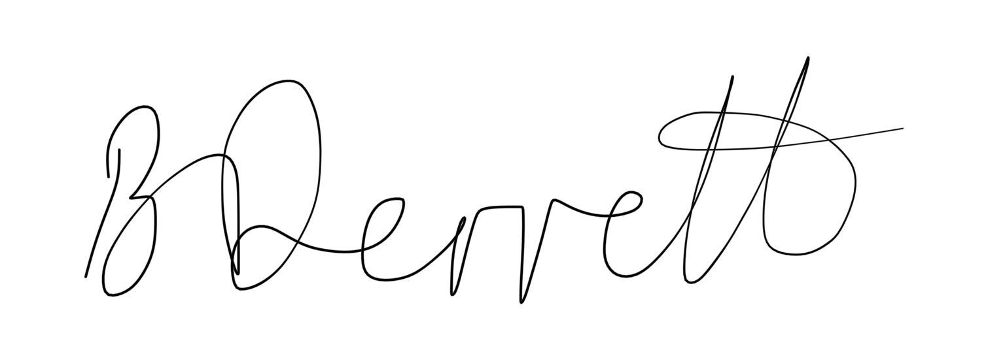
Mrs Beverley Derrett
Headteacher

Sleeping Beauty

Wednesday 8th January, 2025.

I give permission for …………………………………………………………………………..

to go to the New Wolsey Theatre on Wednesday 8th January

and enclose a contribution of £13 per child

Signed ………………………………………………………

