
Tattingstone Church of England V.C. Primary School
Church Road, Tattingstone, Ipswich, Suffolk, IP9 2NA
Telephone: 01473 328488
Email: admin@tattingstone.suffolk.sch.uk
www.tattingstonecevcpschool.co.uk
Headteacher: Mrs Beverley Derrett
BEd-BSc-MA-NPQH-NPQEL

Turning Small Wonders into Shining Lights
__________________________________________________________________________________________


Monday 11th December, 2023

Dear Parents,

We have booked a whole school trip to see the matinee performance of the pantomime ‘Dick Whittington and his Cat’ at the New Wolsey Theatre on Thursday 18th January, 2024.

We have booked a 70 seater coach so that all of the children will travel to the theatre by coach.

As the performance starts at 1.30 p.m. we will need to leave school by 12.45, therefore there will not be time for the children to have a hot dinner. They will need to bring a packed lunch from home, or a school packed lunch that must be pre-ordered by Friday 12th January.

The performance should finish at approximately 4pm and therefore we ask that you arrange to be at the theatre to pick your child/ren up no later than 4pm please. We will bring the children out to the front of the theatre at the end of the performance; please wait until the children are brought to the front of the theatre before taking your child.

Money raised from the School disco with contribute towards the cost of the coach in addition to a donation made to the school made by a beneficiary that wishes to remain anonymous; therefore we would be grateful for a contribution of just £12.60 per pupil from parents that will cover the remaining coach costs and cost of the theatre ticket. If you wish to apply for remittance, please make an appointment to speak to me. Pupils in receipt of Pupil Premium funding are not exempt from paying for school trips.

Please complete the consent slip and pay via ParentMail.

Yours sincerely

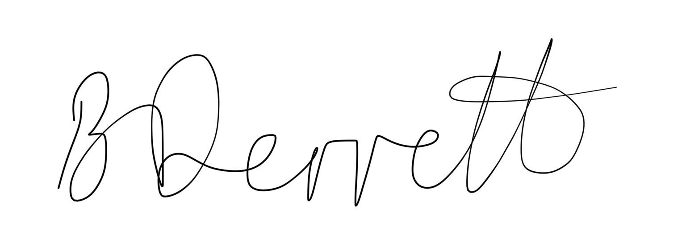
Mrs Beverley Derrett
Headteacher

Dick Whittington and his Cat
Thursday 18th January, 2024.

I give permission for …………………………………………………………………………..

to go to the New Wolsey Theatre on Thursday 18th January

and enclose a contribution of £12.60 per child

Signed ………………………………………………………

