
Tattingstone Church of England V.C. Primary School
Church Road, Tattingstone, Ipswich, Suffolk, IP9 2NA
Telephone: 01473 328488
Email: admin@tattingstone.suffolk.sch.uk
www.tattingstonecevcpschool.co.uk
Headteacher: Mrs Beverley Derrett
BEd-BSc-MA-NPQH-NPQEL

Turning Small Wonders into Shining Lights
__________________________________________________________________________________________

Thursday 10th October

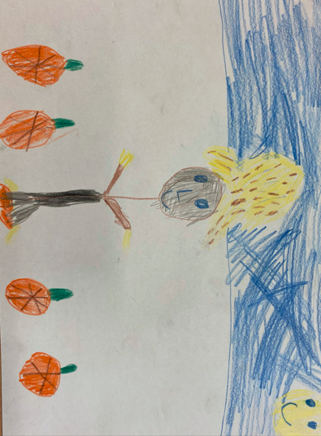
Dear Parents / Carers,
Eco-Council Scarecrow competition
Thursday 17th October 2024
In house groups we are going to be making scarecrows and these will be judged at some point that day. We would like your child to bring in any of the following to use to make their house scarecrow. Only 1 scarecrow will be made per house group so we do not need huge quantities of donations.
Cardboard
Newspapers
Old t-shirts
Thin rope or string
Cable ties
Light tights
Brown sacks
Adult trousers
Sellotape
Hay / Straw
Farmers hat
Colourful wool
Boxes will be put outside the school office and donations can be put in the correct house group box. If we end up getting too many donations, then we will let you know.
We look forward to receiving your donations from Mon 14th October 2024.
Many thanks,
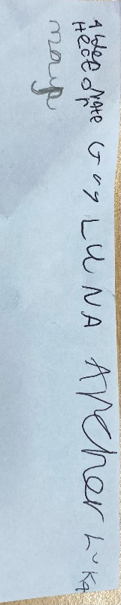
Eco-Council Committee

