
Tattingstone Church of England V.C. Primary School
Church Road, Tattingstone, Ipswich, Suffolk, IP9 2NA
Telephone: 01473 328488
Email: admin@tattingstone.suffolk.sch.uk
www.tattingstonecevcpschool.co.uk
Headteacher: Mrs Beverley Derrett
BEd-BSc-MA-NPQH-NPQEL

Turning Small Wonders into Shining Lights
__________________________________________________________________________________________

Thursday 13th February 2025

Dear Parents and Carers,

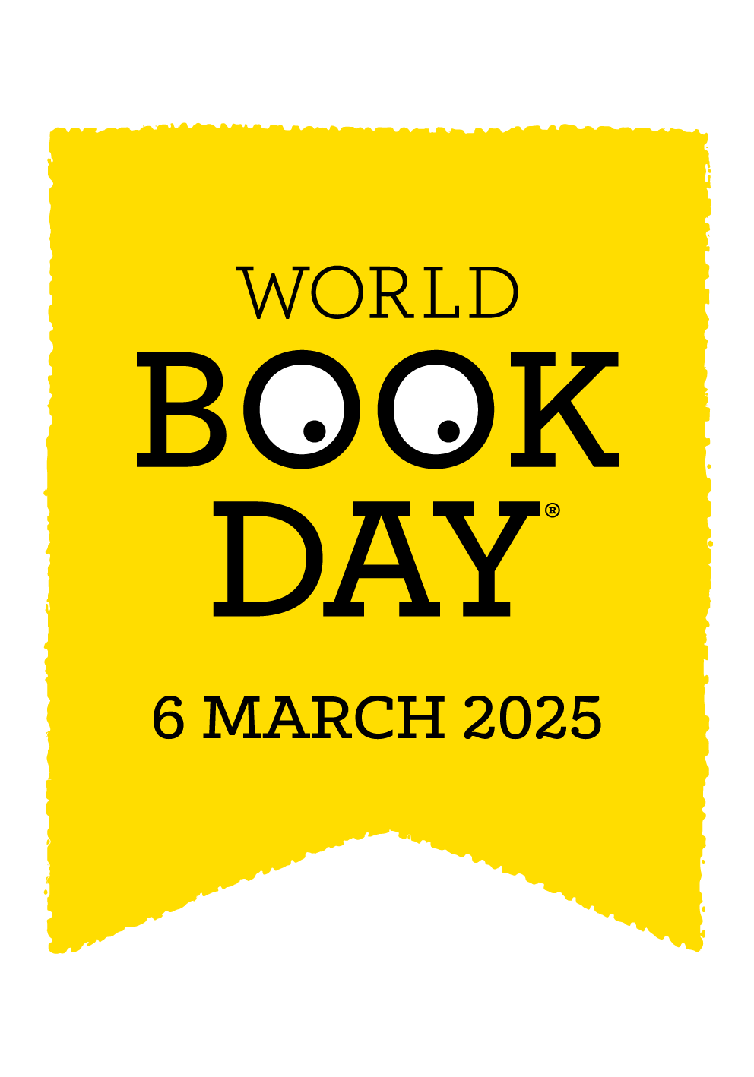

On Thursday 6th March, the children are invited to dress up as a book character for the day. In addition to this, please can your child bring in the book for the character they are dressed as to share with their friends during the day.

The children will receive a £1 World Book Day token. When you get your book token, all you need to do is take it to your local bookseller and swap it for one of the ten (exclusive, new and completely FREE) World Book Day books. Or, if you’d prefer, you can use your book token to get £1 off any full price book instead.

We will also be sending out details of our ‘Readathon’ from Read for Good. More details to follow.

We can’t wait to celebrate our love of books, with your child on this day.

Mrs Cocksedge
Puffins Teacher

