
Tattingstone Church of England V.C. Primary School
Church Road, Tattingstone, Ipswich, Suffolk, IP9 2NA
Telephone: 01473 328488
Email: admin@tattingstone.suffolk.sch.uk
www.tattingstonecevcpschool.co.uk
Headteacher: Mrs Beverley Derrett
BEd-BSc-MA-NPQH-NPQEL

Turning Small Wonders into Shining Lights
__________________________________________________________________________________________

Thursday 13th February 2025

Dear Parent/ Carer,

Science Week 2025

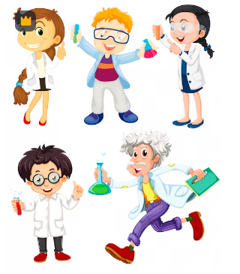

As part of our broad, balanced and creative curriculum we are in the process of planning activities for Science Week 2025.

Dress as a Scientist Day
On Thursday 13th March 2025 we will be holding a come to school dressed as a scientist day whether it is simply crazy hair or a scientist outfit (no school uniform is required). If your child does not wish to come dressed as a scientist please just wear school uniform. If your child would like to take part, then we would ask for a suggested donation of £1. Any donations received will be used to purchase Science equipment to enhance lessons.

Science Homework Project & Exploration Morning on Friday 14th March 2025

Over the next month children of all ages are invited to produce a science project at home. The children may choose anything to do with the Science Association theme of ‘Change and Adapt’. If you have more than 1 child in the school, please encourage them to maybe work together as this is less work for you.

The projects will need to be in school for the morning of Friday 14th March. Families can help their child set up their project in Wings or the Dining hall. Parents are then invited to view the projects between 9.15am – 10am. The project could be any form i.e. practical experiment, poster, booklet or something even more creative! The plan is that when parents or children from other classes visit your child’s project that it is either interactive or they are able to talk about what they found out. It will be lovely to see your child share their home learning and we hope you are able to join us on the day.

Hopefully the information below will give you some ideas for your project.

If you do have any questions, please either catch me at the school gate or speak to Mrs Bartlett and she will pass a message on to me.

Many thanks,

Mrs Cocksedge
Puffins Teacher / Science Co-ordinator

‘Change and Adapt’ and now time to get planning your project

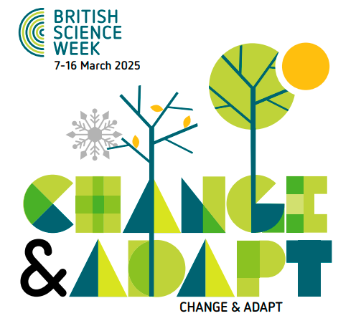

Changing and adapting plays a big part in science; you can find examples in every area of STEM. Cities, towns and other areas where people live change and adapt as the world’s population grows, plants and animals change and adapt to their surroundings to survive. Technology has changed exponentially and adapted to our new, busier lives (or have we changed as technology has developed?). For example, phone technology has changed rotary home telephones to smartphones.

Our behaviours change too – we need to change how we consume the world’s resources to offset the worst effects of the climate crisis, and adapt our lifestyles to reduce our impact through recycling or reducing waste.

But change and adaptation doesn’t just happen here on Earth, even the stars and other celestial bodies change as they gain and lose mass. Perhaps there is life on other planets that adapts as their environment changes.

When exploring this theme, we can also consider how attitudes to STEM and the people who do it have changed and adapted. Perceptions of scientists are changing and we need to keep adapting our thinking until we can no longer picture a ‘stereotypical scientist’ – anyone can be a scientist.

Change and adaptation is often a good thing, but not always! A topic we have all become more familiar with in the last four years, due to the COVID-19 pandemic, is viruses and how they adapt to better infect and multiply within their living hosts. This can be scary, but understanding this behaviour allows scientists to develop the most effective vaccines and other treatments.

On https://www.ascreatives.com/british-science-week-2025/ they included the following ideas for your project:-

EYFS (Understanding My Body): Human Timelines … What happens as we grow from a baby to a child to a grown up to an old person? Why should we celebrate these changes?
Individual in Focus: Frederick Akbar Mahomed, a British doctor, among the first to recognise how individuals can extend their own life spans.

Year 1 (Seasonal Changes): Seasonal Changes … How (and why) do the lengths of our days and nights change through the seasons? How does this help humanity?
Individual in Focus: Eunice Newton Foote, a 19th century America scientist – amongst the first to foresee the effects of human activity on the global a climate.

Year 2 (Animals, including Humans): The Lifespan Game … Why do different species of animals have such widely differing life spans? Can we relate this to life cycles?
Individual in Focus: Kitty Wilkinson, a Liverpool laundress who played a big part in increasing the life expectancy of working class people in Victorian times.

Year 3 (Rocks): Geology Timelines … What is the “fossil record”? How can an understanding of the differences between igneous, metamorphic and sedimentary rocks help us look back on Earth’s immense history?
Individual in Focus: Mary Anning, a British fossil collector whose discoveries changed our understanding of geological timelines.

Year 4 (Electricity): Electricity Timelines … When did humans first start to work with electricity – and how did they do it? How has that led to the current and ongoing quest to create and manipulate electricity in sustainable ways?
Individual in Focus: Granville T Woods, an American inventor, who harnessed static electricity to invent the first ever system allowing moving trains to communicate with stations.

Year 5 (Earth and Space): Space Exploration … How – and why – did humans first start exploring space? How did we move from the Space Race to the Apollo Years, from the Apollo Years to an era of International Collaboration – and are we now moving towards an Age of Business?
Individual in Focus: Caroline Herschel, German-born, British astronomer who calculated comets paths – and discovered at least seven of the bodies!

Year 6/P7 (Evolution and Inheritance): Evolution … How can we use Darwin’s personal timeline as a metaphor for the evolutionary timeline that culminated in humankind.

In addition please see the National Science week website for inspiration:

https://www.britishscienceweek.org/app/uploads/2025/01/British-Science-Week-2025-Primary-activity-pack-Final.pdf

