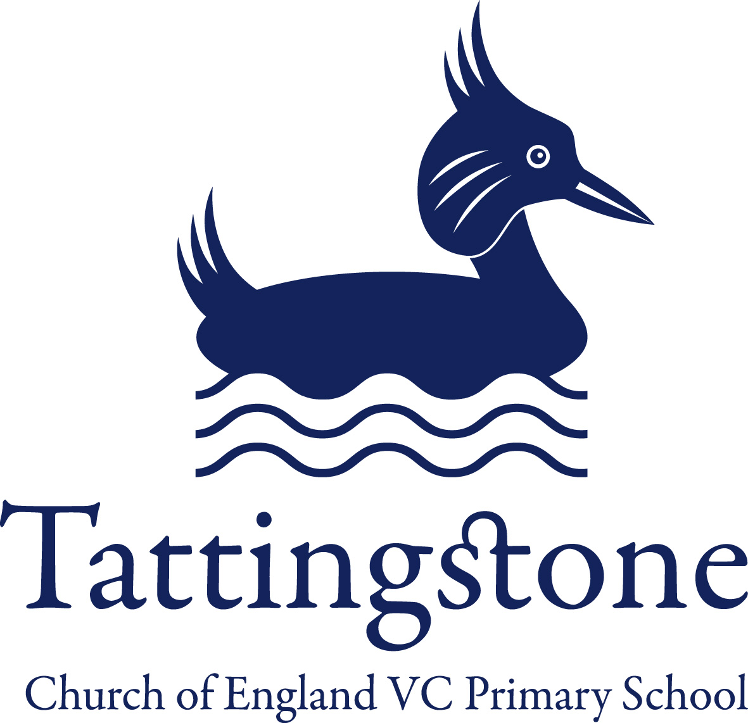
Tattingstone Church of England V.C. Primary School
Church Road, Tattingstone, Ipswich, Suffolk, IP9 2NA
Telephone: 01473 328488
Email: admin@tattingstone.suffolk.sch.uk
www.tattingstonecevcpschool.co.uk
Headteacher: Mrs Beverley Derrett
BEd-BSc-MA-NPQH-NPQEL

Turning Small Wonders into Shining Lights
__________________________________________________________________________________________

27th November 2024

Dear Parents,

On Wednesday 11th December, the school will be holding our Christmas dinner.

On this day the kitchen will provide a roast dinner for our school as below:

Roast turkey, with roast potatoes, Yorkshire pudding and seasonal vegetables and gravy.
Or
Quorn fillet, with roast potatoes, Yorkshire pudding, seasonal vegetables and gravy.

*** *** ***

Festive cookie.

The price will be £2.53 payable via ParentMail for children in KS2, this excludes pupils in receipt of free school meals and KS1.

The kitchen need to know figures in advance for this roast dinner to enable them to cater for the increased number of children who will be having the Christmas dinner at their school as well as Tattingstone.

Therefore, could you please complete the slip below confirming if your child will have this meal and what they would like.

The slip must be returned to the office by Friday 6th December.

If the slip is not returned, your child will need a packed lunch from home on Wednesday 11th December.

Yours sincerely
Nadine Bartlett


Please complete & return to the office by Friday 6th December.

I confirm my child ______________________________ (name) will be having the following for school dinner on Wednesday 11th December:

Tick
Roast turkey, Yorkshire pudding with roast potatoes, seasonal vegetables and gravy

OR

Quorn fillet, roast potatoes, Yorkshire pudding, seasonal vegetables and gravy

Festive cookie
Home Packed Lunch

Yours sincerely
Nadine Bartlett

