
Tattingstone Church of England V.C. Primary School
Church Road, Tattingstone, Ipswich, Suffolk, IP9 2NA
Telephone: 01473 328488
Email: admin@tattingstone.suffolk.sch.uk
www.tattingstonecevcpschool.co.uk
Headteacher: Mrs Beverley Derrett
BEd-BSc-MA-NPQH-NPQEL

Turning Small Wonders into Shining Lights
__________________________________________________________________________________________

12th February 2024

Dear Parent/Carer

Suffolk Show – May 2024
Schools Show Garden Competition – Open to children in Years 3,4,5 and 6 (KS2)

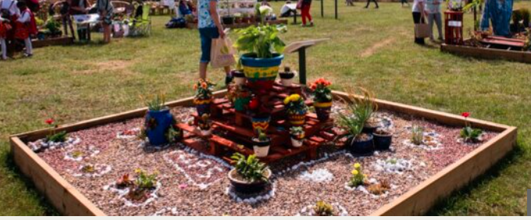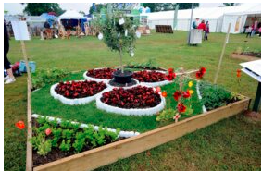

I am pleased to inform you that this year our school has been successful in taking part in the garden competition at the Suffolk Show.
Launched in 2015, the Schools Show Garden Competition gives schools the opportunity to design and build a 1.5m x 1m show garden to reflect the theme which is different every year.

The theme for 2024 is “An Olympic Themed Garden”
A wooden box (including lining and compost) is delivered to our school and then design work, planning and creation takes place at school. The gardens are then collected by the Suffolk Show team and taken to Trinity Park for the two-day event in May half-term. The gardens will be judged on the first day of the Show, Wednesday 29 May, when the winner of the competition will be crowned.

Recently we have started a gardening club with Mr & Mrs Brown and it has been lovely to see so many keen gardeners wanting to take part. Currently the children have been planting and potting flowers and vegetables ready to plant in our raised beds when the weather is warmer. Thank you to Mr & Mrs Brown for giving up your time as it is very much appreciated and lovely to see the children engaging in a different type of activity.
What I am now looking for in addition to our regular keen gardeners is a group of 4-6 children who would like to work together on creating our ‘Olympic Themed Garden’. In order to form this group, I will be looking for your child to complete their own design or what our Olympic Themed Garden could look like and it would be great to combine a few children’s ideas. If your children would rather create a 3D garden as a half term project rather than on paper, then please feel free.
On the link below you can see some examples of what previous winners have done and we are looking for inspiration from your child or family.
https://suffolkshow.co.uk/education/schools-show-garden-competition/
In addition to the wooden box, lining and soil we also receive £75 worth of vouchers to spend at a garden centre. We are happy to purchase fully established plants so details of what you recommend would be appreciated.
The materials for creating our garden are being delivered at the beginning of March and we will need to start asap. If gardening isn’t your thing but you are able to provide any accessories to enhance our garden i.e. outdoor paint for the Olympic rings, mini figures, artificial grass, shingle, roofing felt for running tracks etc. please let me know.
Along with an entry form or model, I am looking for children who are willing to give up some of their break time as and when needed. If children are able to show any of the following qualities this would be amazing:


I look forward to receiving entries by Wednesday 28th February 2024.
If you have any questions, please see me at the gate or speak to Mrs Bartlett in the office and she will pass the message on to me.
Have fun being creative!

Mrs Cocksedge

SUFFOLK SHOW ‘OLYMPIC THEMED’ GARDEN COMPETITION ENTRY

Name____________________________________

Garden Design (size is 1.5 metres x 1 metre)

Items needed to make my garden

Plants needed and what colour-
_______________________________________________________________________
_______________________________________________________________________
_______________________________________________________________________
_______________________________________________________________________
Additional items to put in my garden-

_______________________________________________________________________
_______________________________________________________________________
_______________________________________________________________________
_______________________________________________________________________
Any other comments-

_______________________________________________________________________
_______________________________________________________________________
_______________________________________________________________________
_______________________________________________________________________

