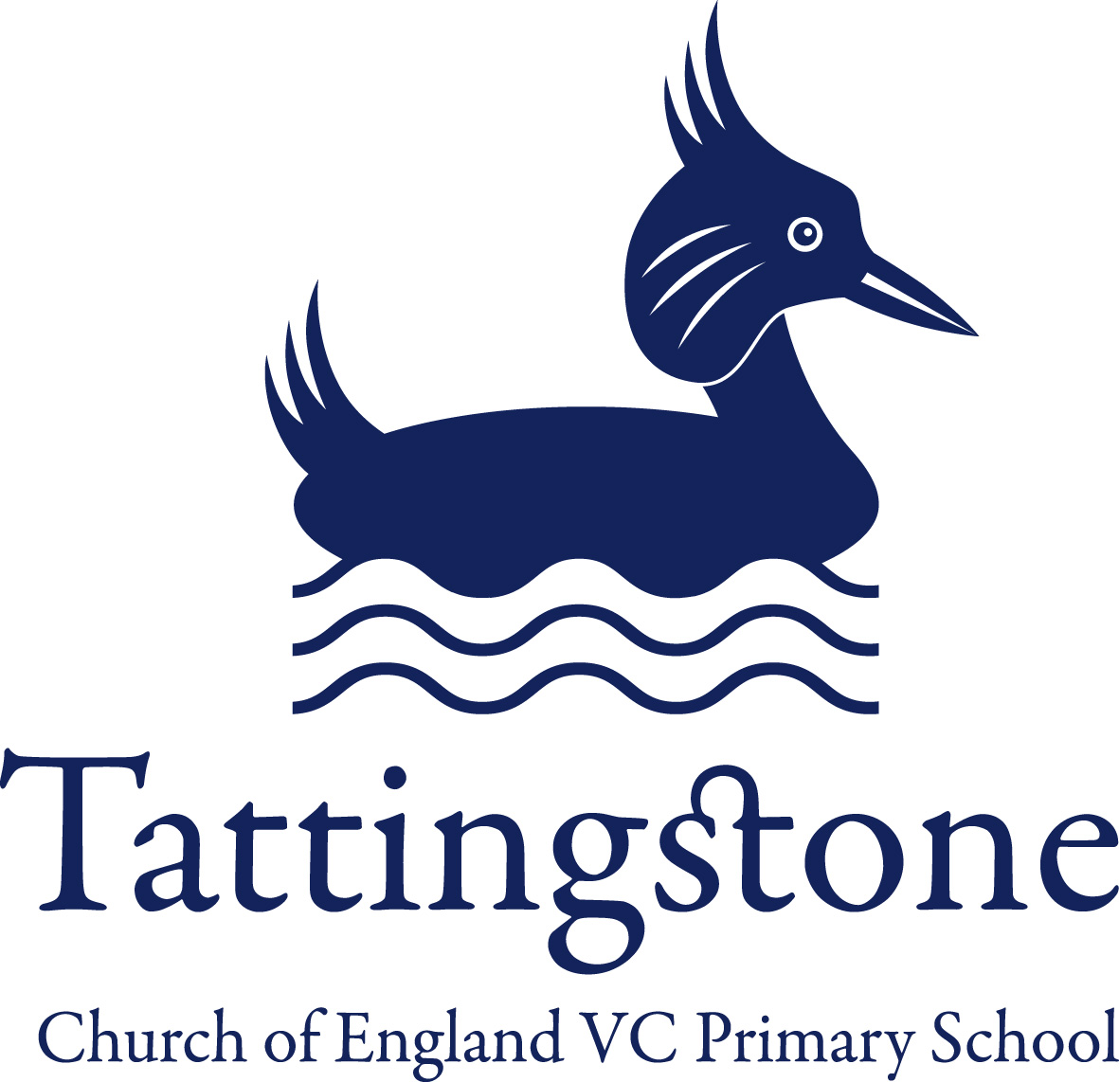
Tattingstone Church of England V.C. Primary School
Church Road, Tattingstone, Ipswich, Suffolk, IP9 2NA
Telephone: 01473 328488
Email: admin@tattingstone.suffolk.sch.uk
www.tattingstonecevcpschool.co.uk
Headteacher: Mrs Beverley Derrett
BEd-BSc-MA-NPQH-NPQEL

Turning Small Wonders into Shining Lights
__________________________________________________________________________________________

Mon 10th June 2024
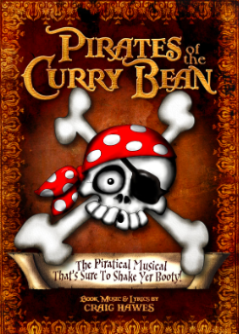

Dear Parent(s) / Carer(s),

Our Summer production is soon approaching and your child……………………………………………………………………………………………

has been chosen to be………………………………………………………………………………………………………………………………………………………………

A list of costume suggestions is over the page and if you do have any questions please ask.

Please can you ensure that the costume is labelled and brought into school by Monday 24th June 2024 in a named carrier bag.

Thanks for all your help and support.

Mrs Jenny Cocksedge
Ducklings and Puffins Teacher / Music Co-ordinator

COSTUME SUGGESTIONS

Stanley Periwinkle (also known as Wonga), Jack & Liza Periwinkle, Pearl Periwinkle - The Periwinkle family need a slight pirate flavour, possibly with black and white striped skirts, trousers and bandanas. Stanley also needs a captain hat as pretends he is Captain Swaggerword in first act.

Street sellers 1-Tick, 2 -Tack, 3 -Toe– Plain top and skirt or trousers and plain or lightly patterned apron

Fiddlesticks – Cat costume

Squawk the Parrot – Parrot costume

Captain Cod, Admiral Horatio Hornhonker & Captain Redbeard – Cod & Hornhonker could wear more elaborate blue & white uniforms whilst Redbeard could have a red “Hook” style costume with a red or pink beard.

Deadly Dinghy - Can wear traditional red and black with striped tops, knee length trousers, bandanas & striped socks/tights

Crew of HMS The Crunchy Frog
Scuttle, Slack, Mr Wally, Mr Pratt, - Pirates can wear traditional red and black with striped tops, knee length trousers, bandanas & striped socks/tights

Sailors
Lockout Lofty, Cutthroat Clegg, Fathom, Fender, Fluke, Gooseneck, Gibbet, Grog - The sailors can be dressed in naval blue and white, with white trousers, blue & white striped tops and sailor hats.

Crew of the Curry Bean
Loopy Louie, Baggywrinkle, Broadside, Bunghole, Blunderbuss, Barnacles, Bamacles, Bullyrag, Bilboe, Bilge - Pirates can wear traditional red and black with striped tops, knee length trousers, bandanas & striped socks/tights

The Natives of Lumago
Ping, Pong, Wiff, Waff - The natives can be costumed in various ways, from Hawaiian style grass skirts to caveman style animal print.

Rats
Rocky Rat, Ronnie Rat, Robbie Rat, Roddy Rat, Reggie Rat, Rickie Rat, Rodney Rat, Romeo Rat, Rodger Rat - Black, Brown or Grey all in one outfit or top and trousers or rat/ mouse costume. We will make masks for each child.

Monkeys
Mickey Monkey, Monty Monkey, Matty Monkey, Macy Monkey, Macky Monkey, Minty Monkey, Misty Monkey, Margie Monkey, Marti Monkey - Black, Brown or Grey all in one outfit or top and trousers or monkey costume. We will make masks for each child.

