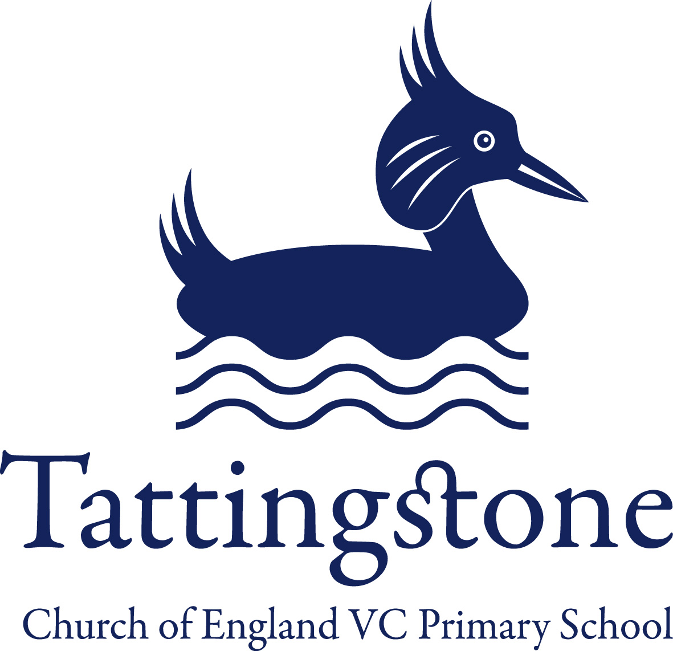
Tattingstone Church of England V.C. Primary School
Church Road, Tattingstone, Ipswich, Suffolk, IP9 2NA
Telephone: 01473 328488
Email: admin@tattingstone.suffolk.sch.uk
www.tattingstonecevcpschool.co.uk
Headteacher: Mrs Beverley Derrett
BEd-BSc-MA-NPQH-NPQEL

Turning Small Wonders into Shining Lights
__________________________________________________________________________________________

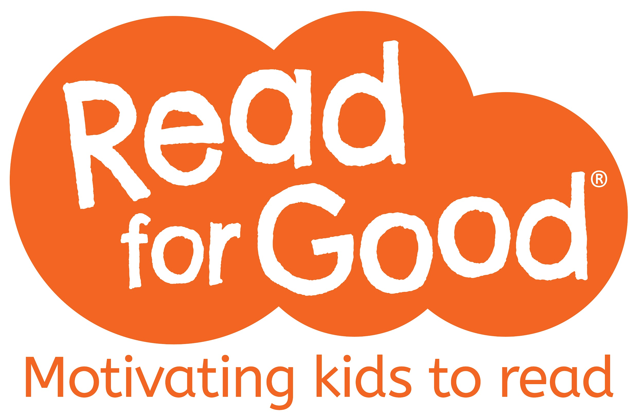
Tuesday 4th March 2025

‘The more that you read, the more things you’ll know.
The more that you learn, the more places you’ll go.’
- Dr. Seuss

Dear Parent or Carer,

We are running a Read for Good Readathon and we’d love your child / children to join in.

It’s been proven that children who read for pleasure are more likely to be successful and happy throughout their lives (OECD, 2002).

The charity Read for Good encourages children to read through its unique motivational approach that inspires reluctant readers to give reading a go and keen readers to read more widely. Pupils can choose whatever they want to read - from comics to classics and audiobooks to blogs - they are not being assessed, it’s all about reading for fun! And, they are motivated to read because the money they raise in sponsorship helps to provide a regular supply of brand new books and a resident storyteller to every major children’s hospital in the UK.

The evidence from other schools is clear: teachers, parents and pupils all say that the freedom to choose what to read, combined with the knowledge that they are directly helping children in hospital, makes participation easy and compelling.

All you have to do is:

- Take a look at what they plan to read, or help them complete their list of books to read. Remember they can read whatever they want: books, e-books, poetry, comics – anything goes! Sharing books is fine too (in fact recommended!) as well as listening to audio books.

- Help your child find sponsors among family and friends. The easiest way to sponsor a child is at https://readathon.my.salesforce-sites.com/sponsor (which family and friends can use too) or return the sponsor card with a cheque(s) or cash sent to school.

Please support your child’s sponsored read as much as you can. They’ll be helping kids in hospitals get books, as well as helping themselves, and our school receives free books worth 20% of our grand sponsorship total, so there really is something in it for everyone.

The deadline for returning sponsorship cards to the school office is Monday 31st March.

For more information, check out your child’s sponsorship card and visit www.readforgood.org.

If you have any questions, please do not hesitate to speak to me.

Mrs Cocksedge

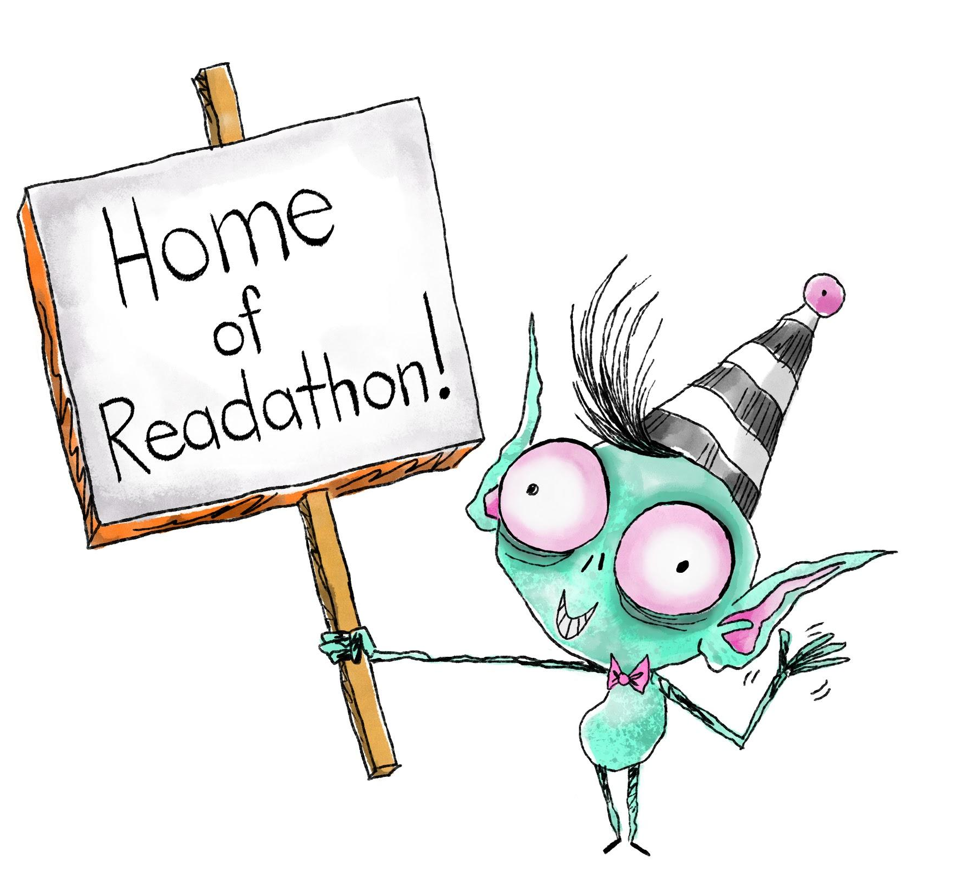

Thank you for your support – helping your child to keep reading, raising
and being amazing!

