
Tattingstone Church of England V.C. Primary School
Church Road, Tattingstone, Ipswich, Suffolk, IP9 2NA
Telephone: 01473 328488
Email: admin@tattingstone.suffolk.sch.uk
www.tattingstonecevcpschool.co.uk
Headteacher: Mrs Beverley Derrett
BEd-BSc-MA-NPQH-NPQEL

Turning Small Wonders into Shining Lights
__________________________________________________________________________________________

Monday 7th October, 2024

Dear Parents
Swimming at Fore Street Pool
for Years 2, 3, 4 & 5
A reminder that swimming for Years 2, 3, 4 & 5 starts on Wednesday morning, 8th January. I will accompany the children to the pool along with Mrs Young. The swimming instructor will meet us at the pool. We also appreciate the help of parents so please let us know if you are able to help either every week or as and when.
The children will have 11 lessons. This is of great benefit to the children as we see huge gains in their skills and progress over this time. In order to be able to continue to offer 11 lessons however, we rely on contributions from parents and request a voluntary contribution of £33.00 towards the cost of these lessons please (Sports premium cannot be used to pay for curriculum PE).
Girls will need a close-fitting one-piece swimming costume and boys will need close-fitting swimming trunks – no Bermuda or swim shorts, the pool does not allow these. Where the Swimming Instructors deem swimming attire to compromise safety they have the right to refuse to teach the child. Pupils are also not permitted to enter the pool without a swimming hat. Goggles may be worn with permission (see reply slip below) and all jewellery, including earrings must be removed.
Yours sincerely
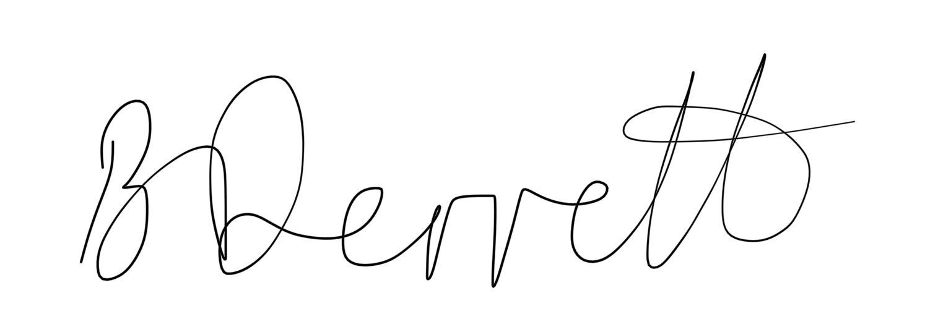
Mrs Beverley Derrett
Headteacher

Swimming at Fore Street - January 2025

Child’s Name……………………………………………………
I enclose a voluntary contribution of £33.00
I am able to help with swimming every week
I am able to help with swimming on certain weeks (state dates below)
I give consent for my child to wear unbreakable plastic or rubber goggles which my child must be able to remove themselves (not essential)

Signed………………………………………………………………………… Print name ……………………………………………………..

