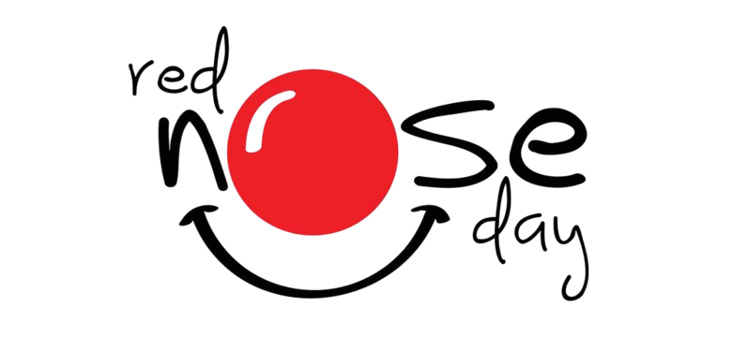

Dear Parents,

Comic Relief is Friday 21st March, in support we will be holding a dress down day allowing the children to come to school dressed in red for a donation.

Comic Relief is celebrating its 40th birthday and to celebrate the children will take part in the Red Nose Day Quiz. The quiz is free to take part in and the children will be put into groups in their house teams.

If children do not wish to dress in red, then please come to school in school uniform.

Kind Regards

Nadine Bartlett