
Tattingstone Church of England V.C. Primary School
Church Road, Tattingstone, Ipswich, Suffolk, IP9 2NA
Telephone: 01473 328488
Email: admin@tattingstone.suffolk.sch.uk
www.tattingstonecevcpschool.co.uk
Headteacher: Mrs Beverley Derrett
BEd-BSc-MA-NPQH-NPQEL

Turning Small Wonders into Shining Lights
__________________________________________________________________________________________

Tuesday 30th September 2025

Dear Parents and Carers,
Framlingham Castle trip
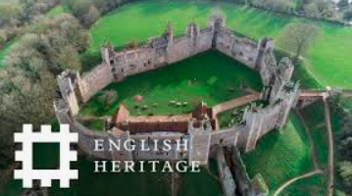

On Friday 10th October, Puffins will visit Framlingham Castle. This links in nicely with our History topic on Castles and I thought our trip would bring their learning to life.

We will leave school at 9.30am at the latest and will be back for lunchtime. If the children can order either a school packed lunch in class or bring in a home packed lunch then this would help should we be late returning. Children will need to wear their school uniform and bring an appropriate coat on the day.

Children are allowed to bring £3 with them to spend in the gift shop. This needs to be exactly £3 and in a sealed envelope with their name on. If children wish to bring a rucksack please ensure this is a small one which they can fit a water bottle in, along with their coat should they need to take a layer off. We will provide a mid-morning snack for your child.

We are very much looking forward to our visit to Framlingham Castle.

Many thanks,

Mrs Cocksedge
Puffins Teacher

Framlingham Castle Permission slip

I give my child permission to visit
Framlingham Castle.

I give permission for my child to be transported to Framlingham by either Mrs Cocksedge /Miss Walker or a parent.

Contact number if event of emergency

Signed Parent/Carer Date

