
Tattingstone Church of England V.C. Primary School
Church Road, Tattingstone, Ipswich, Suffolk, IP9 2NA
Telephone: 01473 328488
Email: admin@tattingstone.suffolk.sch.uk
www.tattingstonecevcpschool.co.uk
Headteacher: Mrs Beverley Derrett
BEd-BSc-MA-NPQH-NPQEL

Turning Small Wonders into Shining Lights
__________________________________________________________________________________________

Monday 12th February, 2024

Dear Parent/ Carer,

Science Week 2024

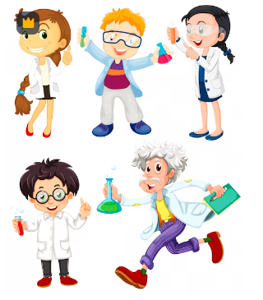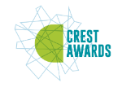

As part of our broad, balanced and creative curriculum we are in the process of planning activities for Science Week 2024. All children are going to be given the opportunity to achieve a Crest Award by completing a number of Crest activities while at school. More information can be found on https://www.crestawards.org/ . This is a great way of achieving an award but also having a lot of fun along the way. We will dedicate time over Science week to complete some of the set activities in order for your child to hopefully achieve the award.

Dress as a Scientist Day
On Thursday 14th March 2024 we will be holding a come to school dressed as a scientist day whether it is simply crazy hair or a scientist outfit (no school uniform is required). If your child does not wish to come dressed as a scientist please just wear school uniform. If your child would like to take part, then we would ask for a suggested donation of £1. Any donations received will be used to purchase the Crest awards which includes certificates and badges and any science resources we might need to make the week successful. Thanks for your support in advance.

Science Homework Project & Exploration Day on Tuesday 12th March

Over the next month children of all ages are invited to produce a science project at home. The children may choose anything to do with the Science Association theme of ‘Time’. If you have more than 1 child in the school, please encourage them to maybe work together as this is less work for you.

The projects will need to be in school for the morning of Tuesday 12th March. Families can help their child set up their project in Wings or the Dining hall. Parents are then invited to view the projects between 9.15am – 10am. The project could be any form i.e. practical experiment, poster, booklet or something even more creative! The plan is that when parents or children from other classes visit your child’s project that it is either interactive or they are able to talk about what they found out. It will be lovely to see your child share their home learning and we hope you are able to join us on the day.

Hopefully the information below will give you some ideas for your project.

If you do have any questions, please either catch me at the school gate or speak to Mrs Bartlett and she will pass a message on to me.

Many thanks,

Mrs Cocksedge
Ducklings & Puffins Teacher / Science Co-ordinator

‘Time’ to get planning your project

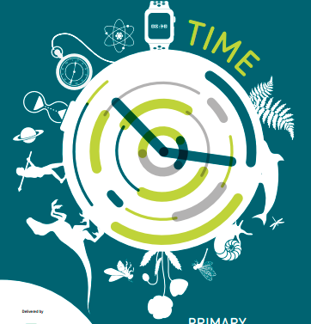

Time is key to so many discoveries in science, technology, engineering and maths. Evolution looks at how plants and animals changed over a long period of time, the Earth’s movements show us why we have seasons and different time zones. In fact, the study of all the celestial bodies in our universe are centred around time; we talk about stars and planets being lightyears away – the distance light travels over a year.

Lifecycles are all about how organisms grow and die during their time on our planet. The average human lifespan is almost 73 years. You could investigate the lifespan of other animals, and how they spend their time.

Scientific innovations are also intertwined with time. The passing of time prompted the invention of ways to mark it, from the sundial, to the pendulum clock to digital clocks – where would be without them? Time is also vital in engineering; complicated machines have moving parts that all need to work in time with each other for the machine to work smoothly. Can you think of any?

Perhaps you could consider the issue food waste by thinking about how passing time impacts different foods. We need to use this knowledge to reduce food waste, perhaps future inventions will help.

On https://www.ascreatives.com/british-science-week-2024/ they included the following ideas:-

EYFS (Understanding My Body): Human Timelines … What happens as we grow from a baby to a child to a grown up to an old person? Why should we celebrate these changes?

Individual in Focus: Frederick Akbar Mohamed, a British doctor, among the first to recognise how individuals can extend their own life spans.

Year 1 (Seasonal Changes): Seasonal Changes … How (and why) do the lengths of our days and nights change through the seasons? How does this help humanity?

Individual in Focus: Eunice Newton Foote, a 19th century America scientist – amongst the first to foresee the effects of human activity on the global a climate.

Year 2 (Animals, including Humans): The Lifespan Game … Why do different species of animals have such widely differing life spans? Can we relate this to life cycles?

Individual in Focus: Kitty Wilkinson, a Liverpool laundress who played a big part in increasing the life expectancy of working class people in Victorian times.

Year 3- (Rocks): Geology Timelines … What is the “fossil record”? How can an understanding of the differences between igneous, metamorphic and sedimentary rocks help us look back on Earth’s immense history?

Individual in Focus: Mary Anning, a British fossil collector whose discoveries changed our understanding of geological timelines.

Year 4 - (Electricity): Electricity Timelines … When did humans first start to work with electricity – and how did they do it? How has that led to the current and ongoing quest to create and manipulate electricity in sustainable ways?

Individual in Focus: Granville T Woods, an American inventor, who harnessed static electricity to invent the first ever system allowing moving trains to communicate with stations.

Year 5 - (Earth and Space): Space Exploration … How – and why – did humans first start exploring space? How did we move from the Space Race to the Apollo Years, from the Apollo Years to an era of International Collaboration – and are we now moving towards an Age of Business?

Individual in Focus: Caroline Herschel, German-born, British astronomer who calculated comets paths.

Year 6 - (Evolution and Inheritance): Evolution … How can we use Darwin’s personal timeline as a metaphor for the evolutionary timeline that culminated in humankind.

In addition please see the National Science week website for inspiration:

https://www.britishscienceweek.org/app/uploads/2024/01/British-Science-Week-Early-years-activity-pack-2024.pdf

https://www.britishscienceweek.org/app/uploads/2024/01/British-Science-Week-Primary-activity-pack-2024.pdf

