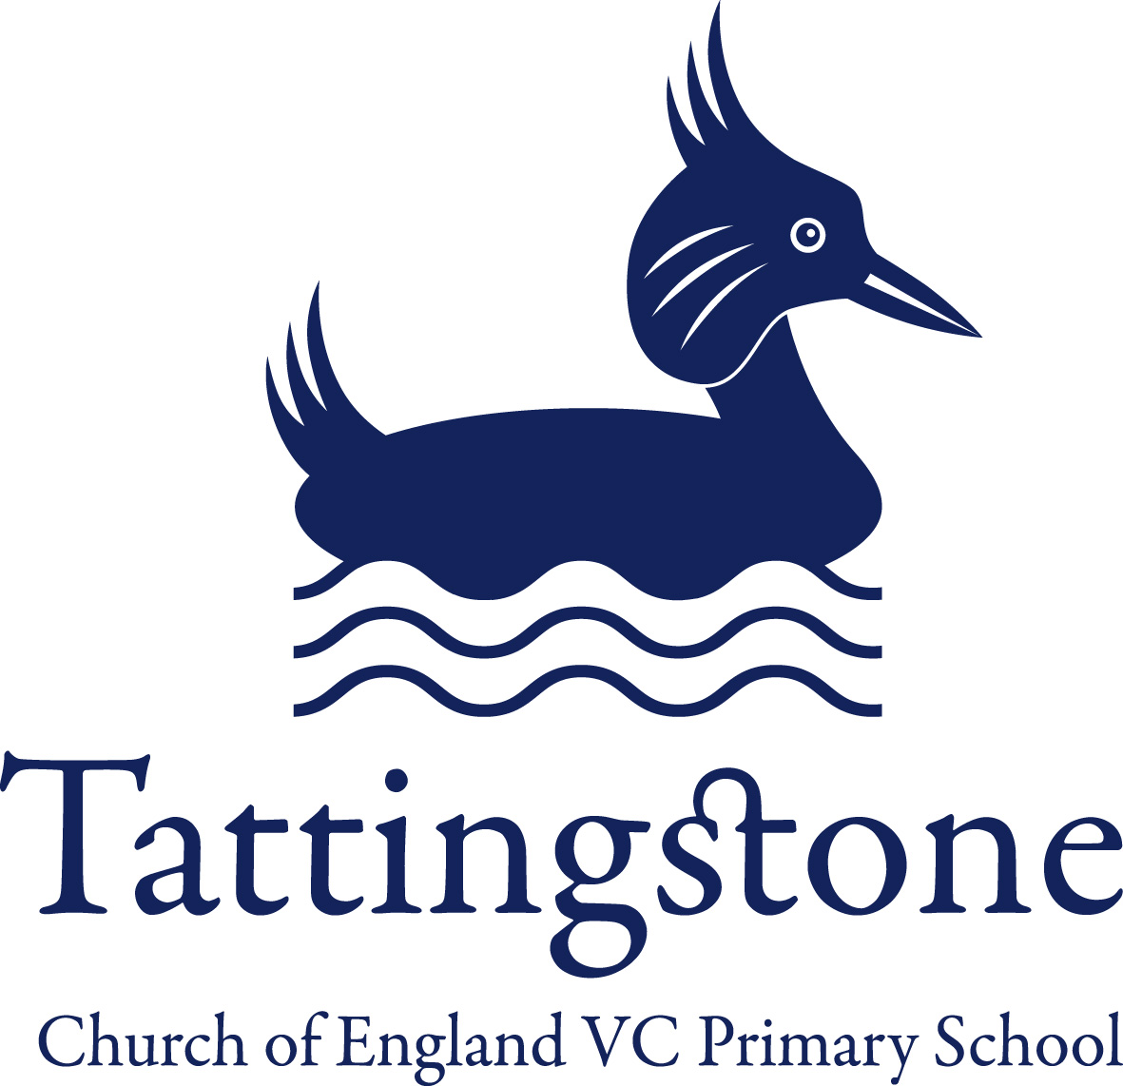
Tattingstone Church of England V.C. Primary School
Church Road, Tattingstone, Ipswich, Suffolk, IP9 2NA
Telephone: 01473 328488
Email: admin@tattingstone.suffolk.sch.uk
www.tattingstonecevcpschool.co.uk
Headteacher: Mrs Beverley Derrett
BEd-BSc-MA-NPQH-NPQEL

Turning Small Wonders into Shining Lights
__________________________________________________________________________________________

Thursday 18th January 2024
Dear Parents/ Carers,

02 Young Voices
On Monday 29th January 2024 we will be attending Young Voices at the 02 Arena in London which I know the children are very excited about.
I thought it would be useful to provide you with some rough timings for the day.
On the day
8.50 am – Children go to classes and register
9.30am – Leave for O2
10.45am – Arrive at Lakeside Services
12pm – Leave Lakeside Services
1.30pm –Registration at O2 for Concert (Only Staff / Children are allowed in at this time)
2pm - 5pm – Rehearsal
5pm – 6pm – Break for eating packed lunches
(All children need to bring a packed tea along with plenty of drinks for the day and I suggest a minimum of 3 drinks – this will all need to be packed in a rucksack)
6pm – Parents can arrive at the Arena
7pm – 9pm – Concert
9pm – Children will be escorted out of the Arena and all children will be taken the coach park. If you are taking your child home and they are NOT going on the coach for the return journey then we will need you to meet us at the coach bay. We will provide details on the day as to where the coach has parked.

Reminders for day / Frequently asked questions:-

*All children need to wear their school uniform on the day as well as bringing a coat.

*Children will need to bring food and drink for the day i.e. for tea before the concert and if they are not having a Burger King. Children also do not need to bring any money with them. Please pack this all in a rucksack.

*Will I be able to see my child? We have a school banner however I recommend bringing a pair of binoculars with you and some Christmas lights so we can see you. These are able to be used before the concert starts but not during.

*T-shirts and torches have arrived and will be handed out to your child on the day

Young Voices Concert Tickets

All tickets for the Young Voices Concert now need to have to be accessed by ‘The O2 Venue App’. They are no longer providing paper tickets.

All parents/carers therefore need to download the app and create an account so I can transfer the tickets to your account. The email address you set up the account with is the one I need to know so I can ensure I send the tickets to the correct address.
So next steps are:-
1 - Get the Venue app (iOS or Android).
2 - Open the app and create an account.
3 – Mrs Cocksedge will transfer tickets to your app
3 - Show your tickets at the O2 on the app for them to scan and you can enter.

I would prefer to transfer the tickets in person so I will need to arrange a time for all parents to come in so we can sort this out. Sounds so simple when you only have a handful of tickets.


Burger King for Young Voices Concert
****Order forms and money to be brought into school by Wed 24th January otherwise I will assume your child will be taking a packed lunch ****

If you would like to order a Burger King for your child for Monday lunchtime then please complete the form below and place this in an envelope with the correct money enclosed. Meals at the Services cost a lot more and are different from the Lakeside Shopping Centre prices. A £2 charge has been added to each meal to hopefully cover price increases. If there is any change then this will be calculated and handed back at the latest the week after the concert. An

Child’s name……………………………………………………………………………………………..

Amount enclosed in envelope……………………………………………………………

CHILDRENS MEALS | Water | Capri Sun – Orange | Capri Sun – Apple & Blackcurrant
Cheeseburger Meal
£7.00 includes extra £2
Hamburger Meal
£7.00 includes extra £2
Chicken Nugget Meal
£7.00 includes extra £2
Vegan Nugget Meal
£7.00 includes extra £2 (Was not available May 2022)

ALL MEALS INCLUDE FRIES

ADULT MEALS |  | Diet Coke | Coke | Fanta | Sprite | Water
Bacon Double Cheese Burger Meal £11.00 includes extra £2
Whopper Meal £11.00 includes extra £2
Chicken Royale Meal £11.00 includes extra £2
Chicken Nugget Meal (9 nuggets) £11.00 includes extra £2
Vegan Royale Meal £11.00 includes extra £2
ALL ADULT MEALS INCLUDING MEDIUM FRIES

If you do have any questions please do catch me at the gate or speak to Mrs Bartlett in the office.
Many thanks,
Jenny Cocksedge

