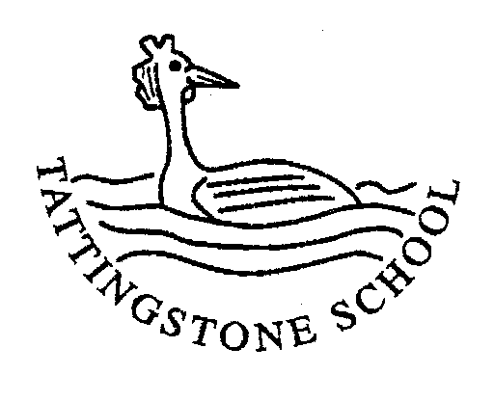

Tattingstone C E V C Primary School

Tattingstone Church of England V C Primary School
Church Road
Tattingstone
Ipswich
Suffolk
IP9 2NA
Telephone & Fax: 01473 328488
E-mail: ad.tattingstone.p@talk21.com
___________________________________________________________________________________________________

Wednesday 21st September 2005

Dear Sir/ Madam,

Re: Primary School Survey of Grasmere Village

At Tattingstone Primary School, the children in Classes 2 and 3 are finding out about their own village and comparing it to the village of Grasmere. Some of our children were lucky enough to visit Grasmere last Summer, and it is for this reason that we have chosen this village in a mountain locality for our primary school geography topic. We have collected together lots of photographs of Grasmere, but would really like to add the information provided by some of the residents to our study, so that we can draw some more detailed conclusions about the village of Grasmere.

We are sure that you probably receive lots of requests from school children for help with their projects, as Grasmere is a honey-pot site for tourists. However, we would be incredibly grateful if you could take the time to answer our 5 short questions and return the questionnaire in the pre-paid envelope. This would help our children immensely in their studies and give them some real data to work with.

Yours sincerely,

Mrs K Bilner & Mrs S Skillern
(Class 2 & Class 3 teachers)

……………………………………………………………………………………………………….

What are the walls of your house made of? __________________________

2. What material is your house roof made of? __________________________

3. If you work, in which town or village do you work? __________________________

4. If anyone in your household is school-age, in which town or village do they go to school?

Primary School child ______________ Secondary School child _______________

Name 3 buildings which you consider interesting or essential in your village

___________________ __________________ _________________
Thank you for completing our questionnaire.
All the children at Tattingstone C E V C Primary School.
Relationships & Sex Education Policy

1. Purpose
The Governors and teachers of Tattingstone C E V C Primary School believe that effective Relationship and Sex Education (RSE) is a vital part of a rounded curriculum that will help children to become happy, safe, healthy, confident and independent adults able to manage the challenges and opportunities of modern Britain. We believe that RSE is a child’s entitlement.

The purpose of RSE is to support children, at each Key Stage, with their physical, emotional, spiritual and cultural development and to address issues such as healthy relationships (including online), puberty, sexual orientation and development and trans-gender issues. It aims to help children have respect for themselves and for others and progress with confidence through childhood and towards adolescence and adulthood.

RSE is provided within the context of the school’s broad programme of Personal, Social and Health Education (P.S.H.E.), Science, Assemblies and in informal ways through the life of the school in addition to discrete teaching in Years 4,5 and 6.

2. Policy Statement

Effective RSE can make a significant contribution to the development of the personal skills needed by pupils if they are to establish and maintain relationships. It also enables young people to make responsible and informed decisions about their health and well-being.

Other related policies and documents that should be read in conjunction with this policy include the PSHE & Citizenship policy, Anti-Bullying Policy, Drug Education Policy, Collective Worship Policy, Safeguarding Policy and the Single Equality document.

3. Aims and Objectives
This policy provides guidance and information on all aspects of RSE in the school for staff, parents/carers and governors.

Key Objectives
- Develop knowledge and understanding of positive and healthy relationships and the importance of commitment.
- Make pupils aware of their rights especially in relation to their bodies.
- Enable the development of social and relationship skills and protective behaviours.
- Prepare pupils for the physical and emotional changes of puberty.
- Explore a range of attitudes, values and faith perspectives around aspects of relationships.
- Support pupils to use the internet safely and to recognise the benefits and risks that it brings.
- Develop pupils’ skills around assessing risk and keeping safe.
- Enable children to gain the skills and understanding to support the development of healthy bodies and minds.
- Enable pupils to recognise and manage their emotions.
- Provide pupils with the knowledge and skills to access appropriate support.

4. Moral and Values Framework
The RSE programme at Tattingstone School reflects the school ethos and demonstrates and encourages the following values:
- Respect for self.
- Respect for others.
- Responsibility for their own actions and decisions
- Responsibility for and understanding of their family, friends, school and wider community.

The programme offered within school is seen as a partnership between home and school. The school acknowledges that parents are the key people in teaching their children about relationships, sex and growing up, and in supporting the development of important values and attitudes, personal and social skills in their children.

5. Equal Opportunities Statement
The school is committed to the provision of RSE to all of its pupils. Our programme aims to respond to the diversity of children’s cultures and family backgrounds, and reflects the Christian ethos of the school. Provision will be made for all classes to access clear age-appropriate information, to discuss attitudes and values, and to develop solid relationships in which children learn how to manage their feelings and behaviour.

6. Content
The Relationship and Sex Education curriculum will be taught in three ways:
- Through the Science curriculum
- Through the PSHE curriculum
- Through discrete RSE (puberty) lessons to Year 4,5 and 6 pupils
- In informal ways through the life of the school

At Tattingstone we follow a PSHE/RSE scheme of work from Kapow Primary which ensures full curriculum coverage. Each year group will be taught through five main strands (six strands in year 6). See below:
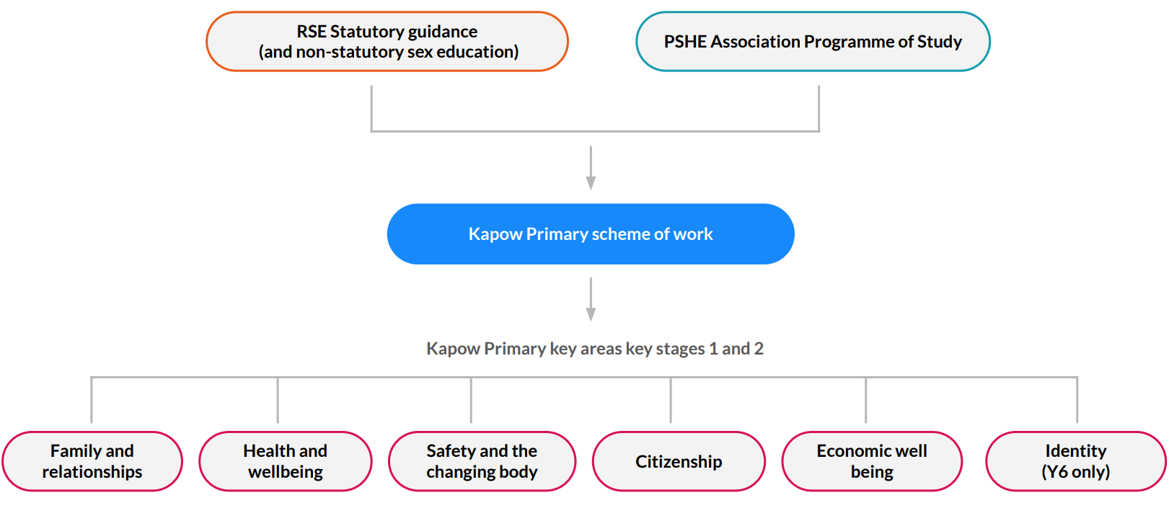

In the families and relationships strand pupils learn:

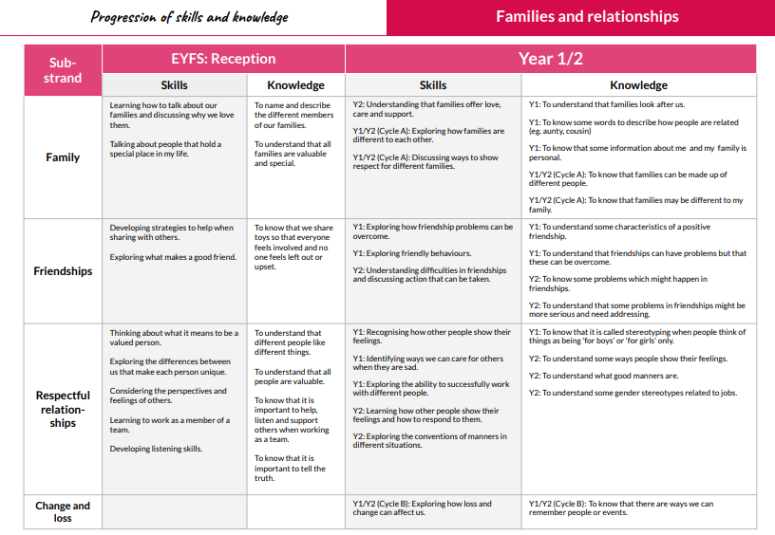

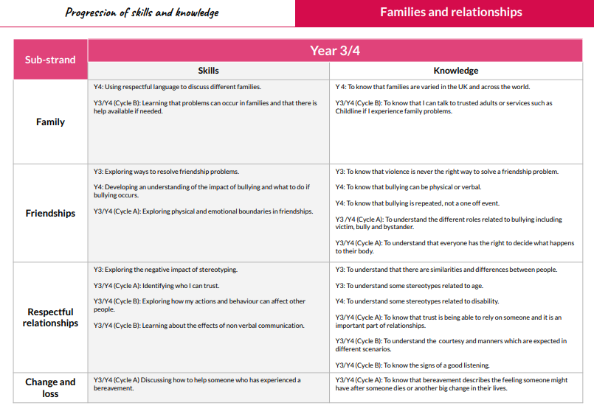

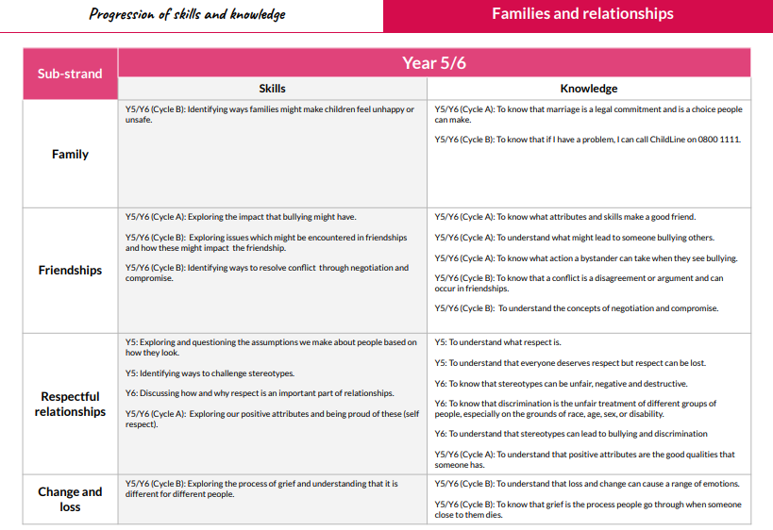

In the health and wellbeing strand pupils learn:

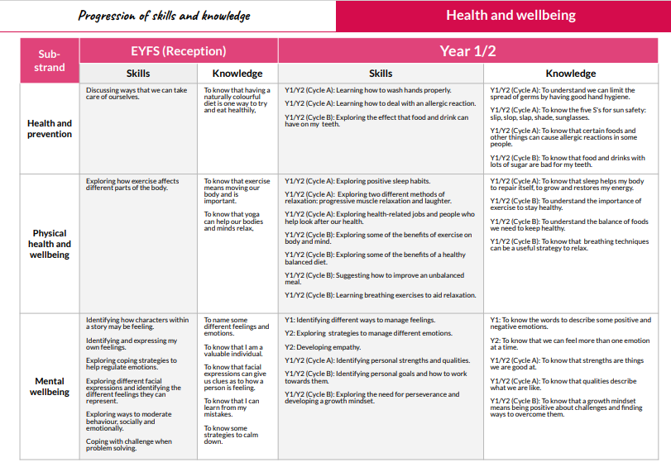

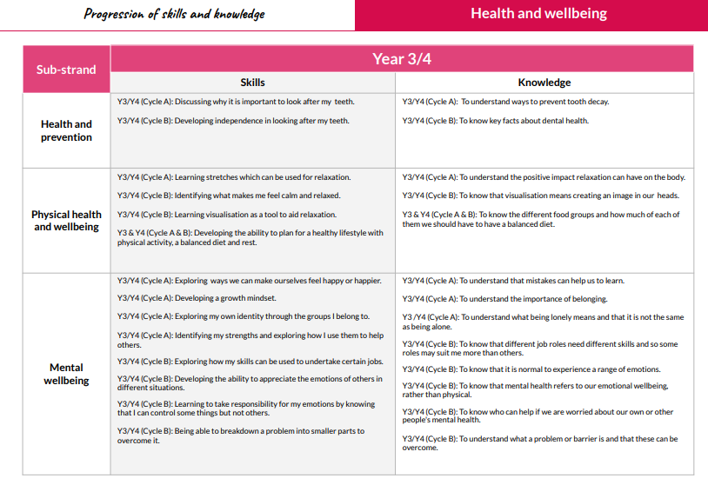

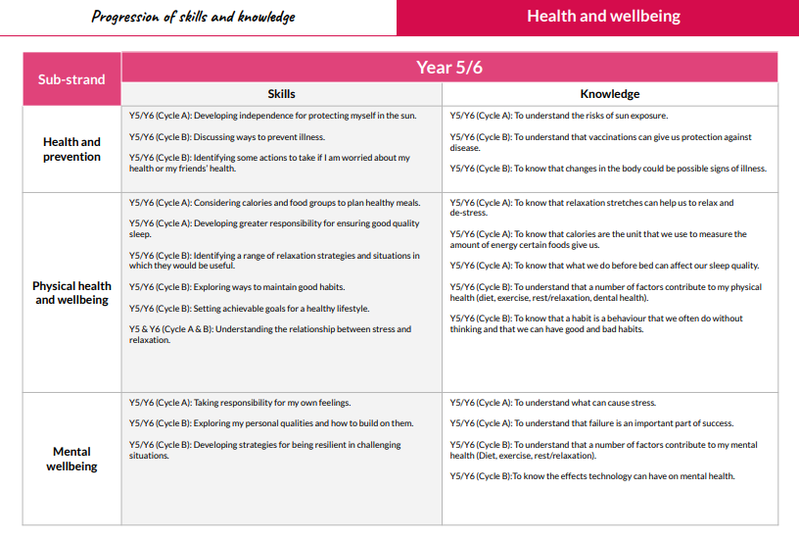

In the safety and changing body strand pupils learn:

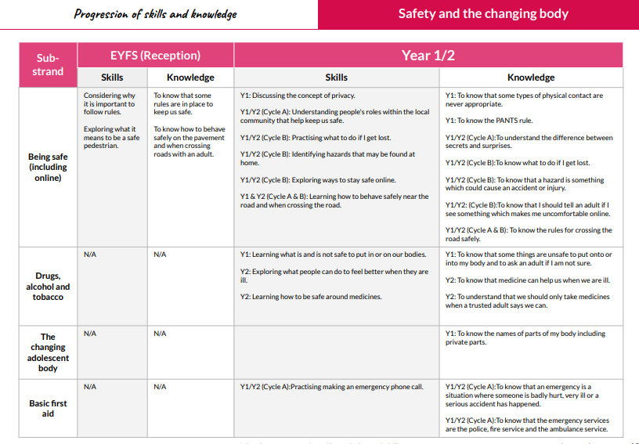

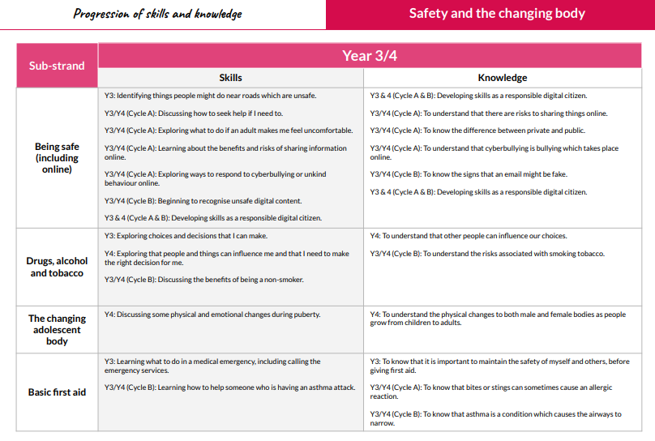

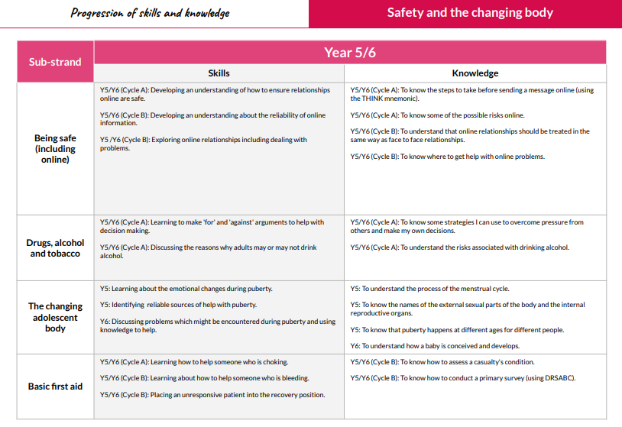

In the citizenship strand pupils learn:
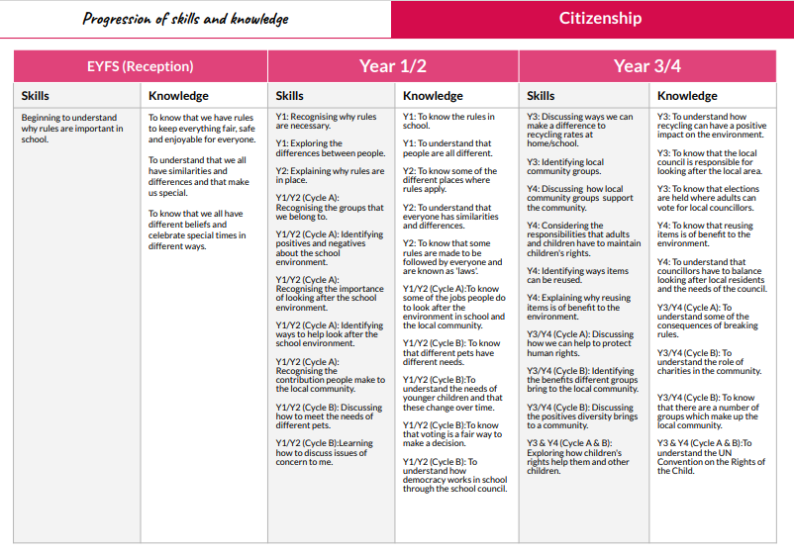

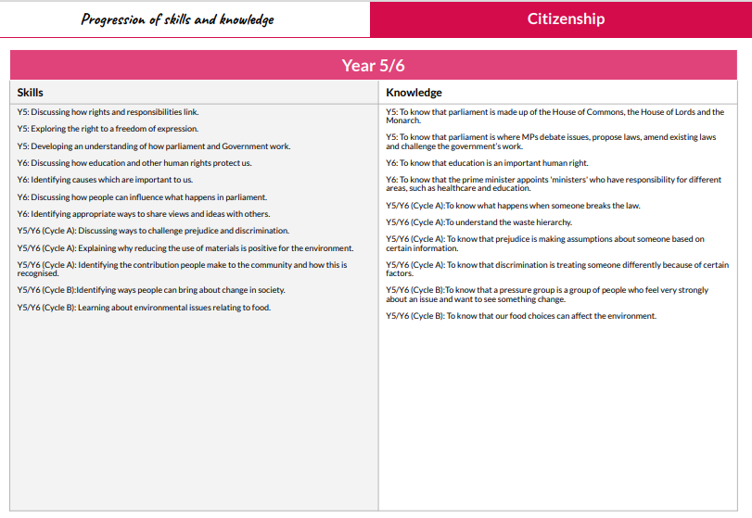

In the economic wellbeing strand pupils learn:

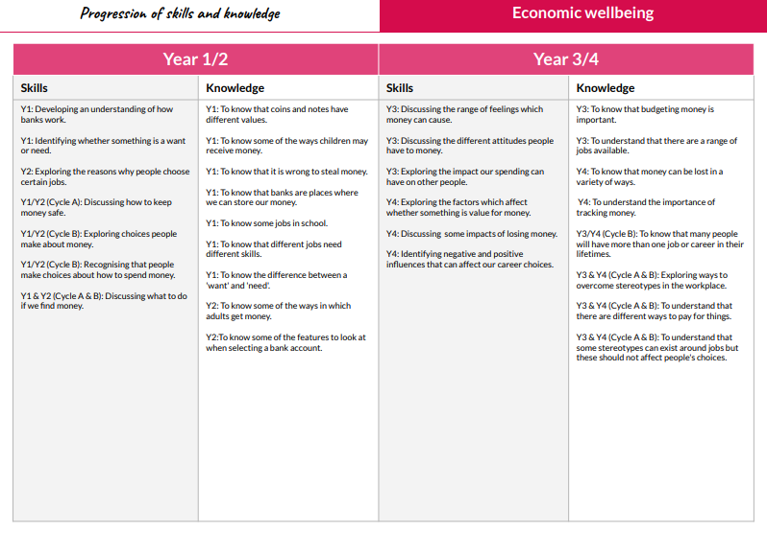

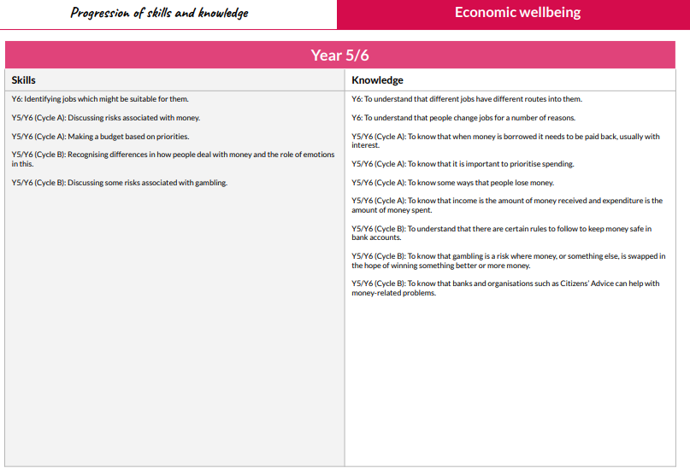

In year 6 there is a separate strand for identity and at each transition there are lessons to help pupils to manage change.
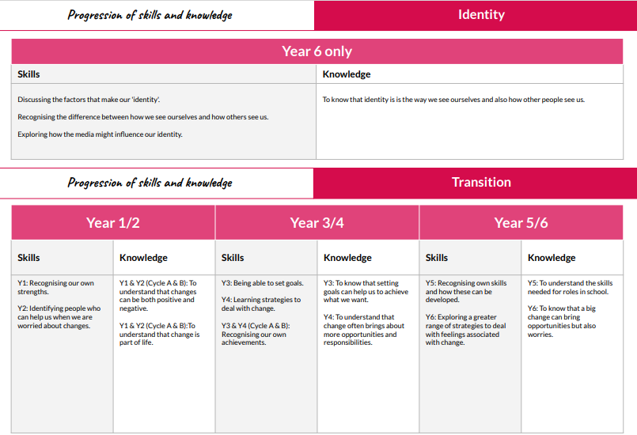

The Kapow PSHE Relationships and Sex Education scheme is used to deliver these aspects of the curriculum and is available on request. Materials used have been chosen carefully to reflect the age of the children they are intended for. The range of material used is available to parents/carers on request and informative books are available to children in the library.

7. Organisation
RSE should not be delivered in isolation but firmly embedded in all curriculum areas, including Personal, Social Health Education (PSHE) and citizenship. At Tattingstone School the main content is delivered in PSHE lessons. This ensures a coherent spiral curriculum.

RSE is normally delivered by class teachers in class groups. Teachers will make judgements about topics to be discussed in smaller groups, and a variety of methods will be used to ensure that children with a higher level of curiosity or knowledge can seek answers to more advanced questions in ways that do not impose too much information on others. Teachers will pay particular attention to involving children in establishing clear boundaries for the discussion of sensitive material in order that children feel safe and confident, are open to new information, respectful of others and develop a mature attitude to their learning. Whilst responding to children’s desire for knowledge, teachers will discourage them from discussing personal/ medical issues which may rebound on them in unhelpful ways outside the classroom. Where exceptionally sensitive issues arise, the teacher may ask children to pursue the questions at home with the support of their parents, or point them to other sources of information.

Occasionally, appropriate and suitably experienced and/or knowledgeable visitors from outside school may be invited to contribute to the delivery of RSE in school e.g. the school nurse. Tattingstone School has a code of practice for using visitors to support the delivery of PSHE:
- Visitors are invited in to school because of the particular expertise or contribution they are able to make;
- All visitors are familiar with and understand the school’s RSE policy and work within it;
- All input to PSHE lessons are part of a planned programme and negotiated and agreed with staff in advance;
- All visitors are supervised/supported by a member of staff at all times;
- The input of visitors is monitored and evaluated by staff and pupils. This evaluation informs future planning.

Elements of sex education in the science curriculum are assessed formally. Evaluation of the RSE programme outside the science order is conducted using a variety of informal activities which have been built into the programme. Teachers are required to keep their own evaluation/ assessments of each lesson which are used by the coordinator to inform future planning.

Tattingstone School believes in the importance of training for staff delivering RSE. Staff are encouraged to access appropriate training and support to help them deliver effective RSE.

The RSE curriculum is supported by the quality of relationships on offer throughout the school and by adults’ responses to routine questions from children. All staff will therefore be involved in the delivery of some aspects of this policy.

8. Specific Issues within RSE

Withdrawal
Parents/Carers have the right to withdraw their children from all or part of the relationship and sex education provided at school. The science curriculum however includes content on human development, including reproduction, which there is no right to withdraw from. Those parents/carers wishing to exercise this right are invited in to speak to the Headteacher who will explore any concerns and discuss any impact that withdrawal may have on the child. Once a child has been withdrawn they cannot take part in the RSE programme until the request for withdrawal has been removed.

Safeguarding
The school has a separate Safeguarding Policy. Effective RSE, which brings an understanding of what is and what is not acceptable, may bring about disclosures of safeguarding issues and staff are aware of the procedures for reporting their concerns. Children have the right to a safe learning environment and to have their worries notices and acted upon in appropriate ways.

Confidentiality
As a general rule, a child’s confidentiality is maintained by the teacher or member of staff concerned. In an extreme circumstance, if this person believes that the child is at risk or in danger, she/he may report what a child has said, to the Senior Designated Safeguarding Officer or Alternate SDP in school. The child concerned will be informed that confidentiality is being breached and reasons why. The child will be supported by the teacher throughout the process in line with the school’s confidentiality policy.

Controversial and Sensitive Issues
Staff are aware that views around RSE related issues are varied. However, while personal views are respected, all RSE issues are taught without bias. Topics are presented using a variety of views and beliefs so that pupils are able to form their own, informed opinions but also respect that others that may have a different opinions.

Dealing with Questions
Both formal and informal RSE arising from pupils’ questions are answered according to the age and maturity of the pupil concerned. Questions do not have to be answered directly, and can be addressed individually later. The school believes that individual teachers must use their skill and discretion in this area and refer to the Senior Designated Person for Safeguarding if they are concerned.

Sexual Identity and Sexual Orientation
Tattingstone School believes that RSE should meet the needs of all pupils regardless of their developing sexuality and be able to deal honestly and sensitively with sexual orientation, answer appropriate questions and offer support. Homophobic bullying is dealt with strongly yet sensitively in line with the school’s anti-bullying policy. The school liaises with parents on this issue to reassure them of the content and context.

Menstrual Wellbeing
Many pupils will begin menstruation in primary school. To support pupils who are menstruating, we have the following in place:
Sanitary disposal units are provided in the downstairs toilets in the main school building
Pupils can discretely access sanitary products from the school office or the class teacher will organise this.

If a pupil starts menstruating in school, we will support them on-site and inform parents immediately. We will aim to minimise the pupils anxiety with a caring and supportive approach to what can often be a difficult transition.

Dissemination
All staff members and governors receive a copy of the RSE policy. Training is regularly delivered to staff on the policy content. Copies are available from the school office on request from parents. The policy is reviewed on a yearly basis.

November 2023

Reviewed: 2006-2007-2008-2009-2010-2011-2012-2013-2017-2018-2019-2020-2021- 2022 - 2023

Signed……… ………..

Date…………………………………………………………………..

