

**CHILD FRIENDLY**

**SAFEGUARDING POLICY**

Adopted by the school council: -

Review: November 2022

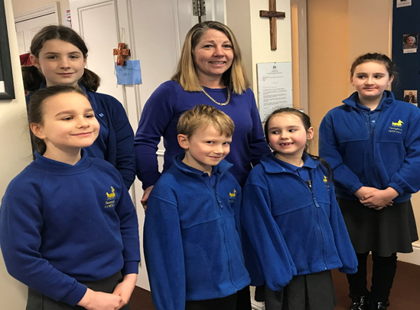

**Feeling SAFE and HAPPY at school** We want to make sure you are healthy and looked after, in and out of your school.

This policy looks at how every grown-up can help make you feel **safe**, and how you can spot if something **bad** is happening.

**We can help you by:**

Only hiring people who can be **trusted** to keep you **safe**.

Teaching you about keeping **safe**, giving you the **strength** to **trust** your **feelings**

Helping you if someone does not keep you **safe**.

Making sure all adults at the school know what they have to do.

Making child friendly information available around Tattingstone School.

Talking about our feelings and respecting other peoples.

**Sometimes we don’t know if something bad is happening, so you need to tell us.**



**Grown-ups and other children**

The grown-ups in your life are there to **help** and **care** for you, but sometimes

grown-ups do bad things to children.

Sometimes they say and do things that can upset or hurt you.

A **trusted** grown-up can help you, but you need to tell them what is happening. You need to **trust** them

Children at Tattingstone are here to learn and try their best, just like you. Most children are friendly, but some can make us feel **worried**. It is okay to tell a trustedgrown up how you feel.

**Make a list below of trusted grown-ups at your school.**

* Teachers
* Mrs Derrett
* Teaching assistants
* The office staff

**How do you know?**

* Badges must be worn
* Pictures of staff and governors in the office

**Feeling safe and unsafe**

Playing with your friends or a hug from your mum, dad or carer can make you

feel **protected.** If someone or something makes you feel unsafe or frightened, tell

a **trusted** grown-up and they will make it stop. It is **good** to be **honest** about how you feel.**

**Touch**

There are **good** and **bad** touches.

Good touches:

• A hug

• Help with getting dressed

• Holding hands

**Bad** touches can be **scary**, **hurt** or be **rude**.

Parts of the body covered by a swimming costume or your underwear are **private**.

Unless you need help with washing or dressing, or need to see someone like a doctor, **no-one should touch this area on your body.** If a touch makes you feel **scared**, say **no** or make a sign to the person to stop. You should also tell a **trusted** grown-up

**Secrets**

A secret is something we know but try not to tell anyone else. A **good** secret is a birthday party surprise or knowing someone is going to win a prize.

Sometimes we have been **hurt**, are **afraid**, or don’t **trust** what’s happened. If someone says we must keep a **bad** thing a **secret**, that’s a bad secret.

If you think you have been told to keep a **bad secret**, you must tell a **trusted** grown-up.

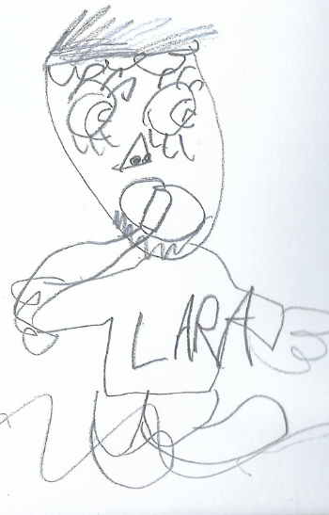

Shhh!

**It is every grown-up in our school’s responsibility to keep you safe and happy**.

You need to tell one of these **trusted grown-ups** if something is done or said to you that hurts or upsets you. They can help you so you can feel **safe** and **happy** again.

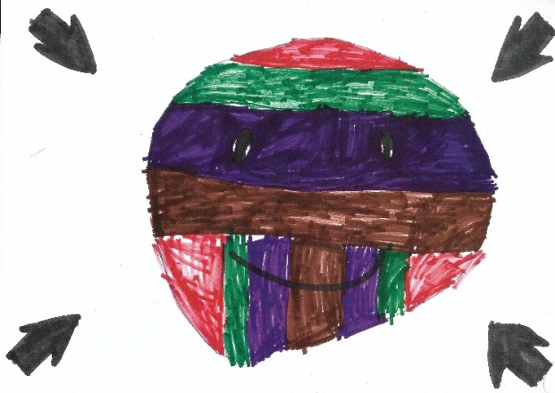

**You can tell a grown-up by:**

• Speaking

• Drawing

• Making signs with your hands, face or body

• Showing or pointing to drawings or photos

After telling a **trusted** grown-up, they can help stop the **bad** things happening, and you can be **safe** and **HAPPY** again.

**Outside of school**

Sometimes things happen outside of school that makes you feel unsafe or causes you to worry. Talk to your family about things that you can do, you might have a word you use in the park to call your safe grown up for example.

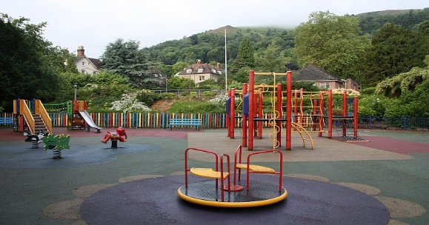

[This Photo](https://www.geograph.org.uk/photo/1362251) by Unknown Author is licensed under [CC BY-SA](https://creativecommons.org/licenses/by-sa/3.0/)