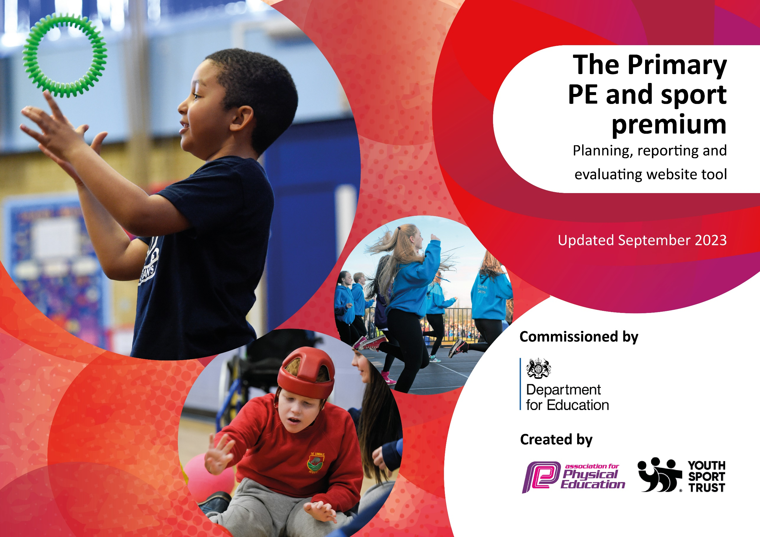
/

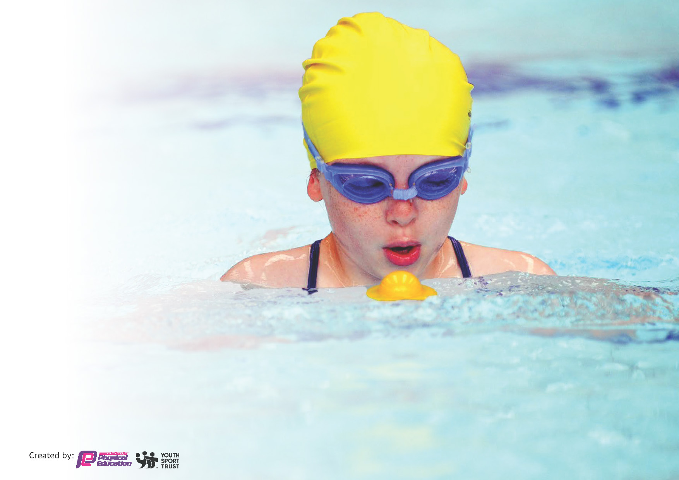
This template can be used for multiple purposes:
by:
- It enables schools to effectively plan their use of the Primary PE and sport premium
- It helps schools to meet the requirements (as set out in guidance) to publish information on their Primary PE and sport premium
- It will be an effective document to support Ofsted inspections enabling schools to evidence progress in Physical Education (PE) and evidence swimming attainment, which forms part of the PE National Curriculum. We would recommend schools consider
the Intent, Implementation and Impact of any spend, as examined within the Education Inspection Framework.

It is important that your grant is used effectively and based on school need.

Schools must use the funding to make additional and sustainable
improvements to the quality of the PE, School Sport and Physical Activity (PESSPA)
they offer. This means that you should use the Primary PE and sport premium to:

- Build capacity and capability within the school to ensure that improvements made now will benefit pupils joining the school in future years
- Develop or add to the PESSPA activities that your school already offers.

The Primary PE and sport premium should not be used to fund capital spend projects; the school’s core budget should fund these. Further detail on capital expenditure can be found in the updated Primary PE and sport premium guidance.

The Primary PE and sport premium guidance, outlines 5 key priorities that funding should be used towards. It is not

necessary that spending has to meet all the key priorities, you should select the priorities that you aim to use any funding towards.

Although completing this template is not a requirement for schools, schools are required to publish details of how they spend this funding. Schools must also outline what the impact this funding has had on pupils’ PE and sport participation and attainment and how any spending will be sustainable in the future. All funding must be spent by 31st July 2024.

The Department for Education has worked closely with the Association for Physical Education (afPE) and the Youth Sport Trust (YST) to develop this template and encourages schools to use it. This template is an effective way of meeting the reporting requirements of the Primary PE and sport premium.
Review of last year’s spend and key achievements (2023/2024)

We recommend you start by reflecting on the impact of current provision and reviewing your previous spend.
Total spend £18,316. Balance remaining £5, 879 – pending £879 equipment restock and £5,000 iPads for sports coaching and tournaments.

Activity/Action (Number refers to the Key Indicator) | Impact | Comments
£3,846 after school sports clubs – BD 5  £1,710 lunchtime sports clubs – MD + DC 1  £732 Forest Schools extra hours – JC + DS 4  £560 2 beach school coaches and activities 4  £400 new pond +£1467 new pond area materials and labour + £156 pond pump, locks and netting 4  £300 sailing subsidy 4  £381 skiing subsidy 4  £180 Bikeability 4  £72 develop the reflection area 4  £135 Little Kickers football coaching 4  £1,139 2 scooters, balance bike, medium trike, tuk tuk, and taxi 4  £226 Didicars 4 | Scale and reach, 60 active minutes & inclusion  60 active minutes & inclusion  Physical literacy / positive experiences
£943 Village hall/playing field hire and cleaning 1 |  | As the school does not have a hall or large enough playing field.
£675 School Games membership 1, 2, 4, 5 | To enable us to achieve the School Games Mark
£248 skip hire to clear old PE shed  £908 New PE equipment shed at village hall  £2,512 REJB equipment repairs, new PE mats, pair of netball posts  £300 grounds markings  £733 plastic storage shed for playground equipment  £259 turf for play area  All to enable 1, 4 and 5 to happen | Safe equipment and appropriate resources and markings for lessons and clubs | To enable the gymnastics equipment to be securely stored and kept in a good condition.
£28 tennis balls 1  £100 football goals 1  £276 parachute, table tennis balls, stilts, footballs 1 & 4 | Scale and reach; curriculum

Key priorities and Planning
This planning template will allow schools to accurately plan their spending.

Action – what are you planning to do | Who does this action impact? | Key indicator to meet | Impacts and how sustainability will be achieved? | Cost linked to the action
After school sports clubs | PE Lead and sports coach  pupils – as they will take part. | Key indicator 5: Increased participation in competitive sport.  Key indicator 4: Broader experience of a range of sports and activities offered to all pupils.  Key indicator 1 -The engagement of all pupils in regular physical activity – the Chief Medical Officer guidelines recommend that all children and young people aged 5 to 18 engage in at least 60 minutes of physical activity per day, of which 30 minutes should be in school. | Contributes to 60 active minutes, inclusive to all children wishing to take part, inter-school competition. | £8,000
Village hall and playfield hire and cleaning  School Games Membership  REJB equipment repairs  Ground markings  New equipment | All pupils  Teachers | Key Indicator 1 – engagement of all pupils in regular physical exercise  Key indicator 5: Increased participation in competitive sport.  Key indicator 4: Broader experience of a range of sports and activities offered to all pupils.  Key indicator 3: Increased confidence, knowledge and skills of staff. | The school does not have a hall or playing field facilities, without the village hall and village playing field we could offer a very limited range of sports. School Games membership opens up CPD opportunities and competitions/tournaments for pupils.  REJB ensures all equipment is safe and pupils have suitable and relevant equipment in both curriculum and after-school clubs. | £1,000  £700  £2,500  £300  £500
Forest School  Beach School  Sailing subsidy  Skiing subsidy  Bikeability | All pupils | Key indicator 4: Broader experience of a range of sports and activities offered to all pupils.  Key indicator 2: The profile of PESSPA is raised across the school.  Key Indicator 1 – engagement of all pupils in regular physical exercise | A variety of curriculum and after-school opportunities for the pupils that are beyond the usual curriculum requirements.  Inclusive to all pupils wishing to take part (sailing and skiing – age restrictions) | £800  £1,200  £350  £400  £200

CPD for teachers provided by Paul Skingsly | Primary generalist teachers. | Key Indicator 3: Increased confidence, knowledge, and skills of all staff in teaching PE and sport. | Primary teachers more confident to deliver effective PE supporting pupils to undertake extra activities inside and outside of school, including teaching water safety and swimming and as a result improved % of pupil’s attainment in PE.  More pupils meeting their daily physical activity goal, more pupils encouraged to take part in PE and Sport Activities. | £100
 |  |  |  | £560 remaining

Key achievements 2024-2025
This template will be completed at the end of the academic year and will showcase the key achievements schools have made with their Primary PE and sport premium spending.

Activity/Action | Impact | Comments

Swimming Data
Meeting National Curriculum requirements for swimming and water safety.
Priority should always be given to ensuring that pupils can perform safe self-rescue even if they do not fully meet the first two requirements of the National Curriculum programme of study

Question | Stats: | Further context  Relative to local challenges
What percentage of your current Year 6 cohort can swim competently, confidently and proficiently over a distance of at least 25 metres? | 93.3% | One girl joined the school in Year 4 so only had 2 terms of swimming with us and did not manage to achieve 25 metres.
What percentage of your current Year 6 cohort can use a range of strokes effectively [for example, front crawl, backstroke, and breaststroke]? | 93.3% | Same girl as above.

What percentage of your current Year 6 cohort are able to perform safe self-rescue in different water-based situations? | 93.3% | Same girl as above
If your schools swimming data is below national expectation, you can choose to use the Primary PE and sport premium to provide additional top-up sessions for those pupils that did not meet National Curriculum  requirements after the completion of core lessons. Have you done this? | Yes/No
Have you provided CPD to improve the knowledge and confidence of staff to be able to teach swimming and water safety? | Yes/No | Shallow water certificate

Signed off by:

Head Teacher: | Beverley Derrett
Subject Leader or the individual responsible for the Primary PE and sport premium: | Beverley Derrett – Headteacher and PE Lead
Governor: | Lauren Wade – Parent Governor
Date: | July 2024

