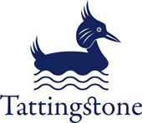 **Tattingstone C E V C Primary School**

**Curriculum Statement 2023**

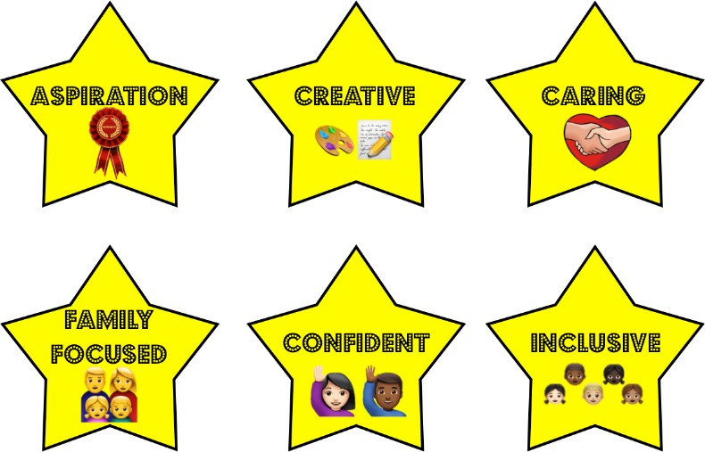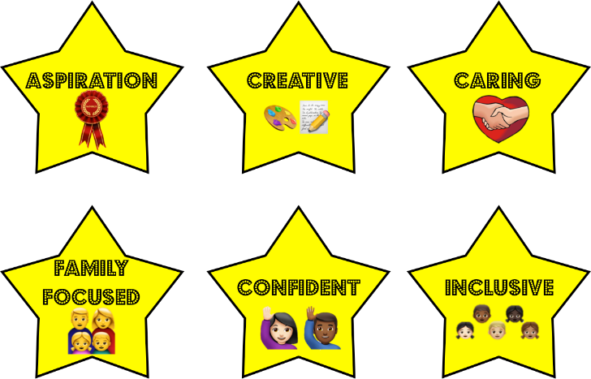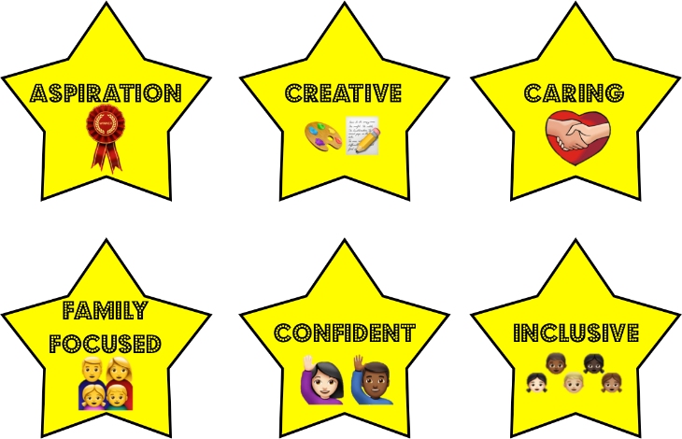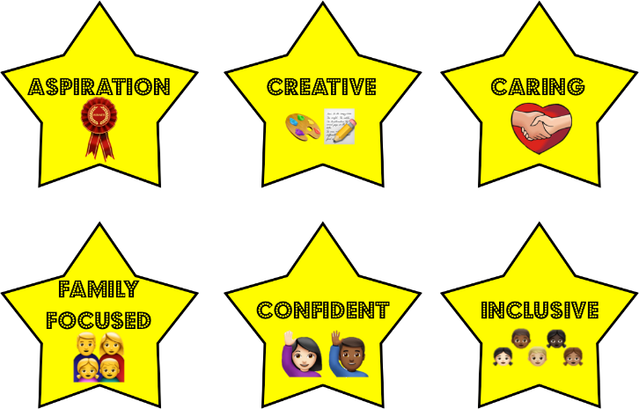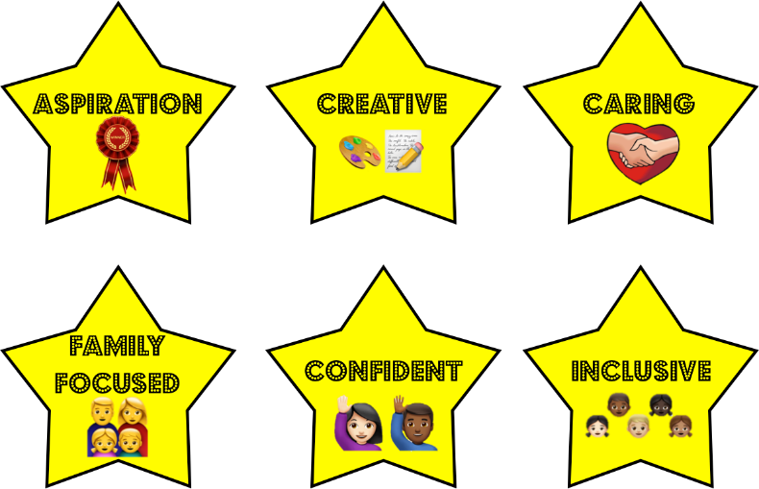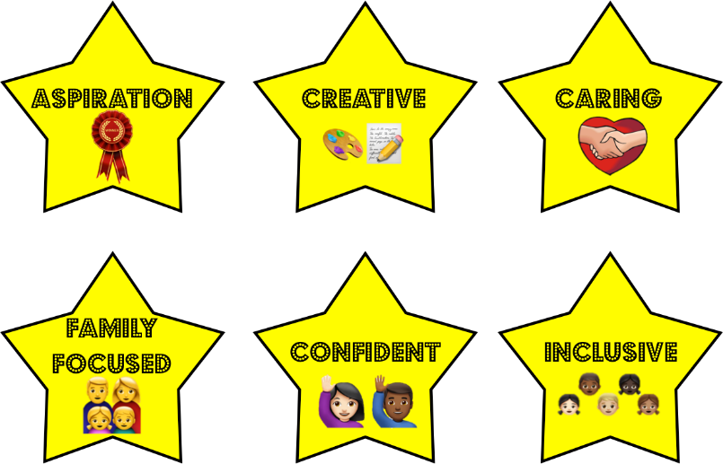

At Tattingstone CEVCP School we aim to provide the children with a curriculum which is broad, well balanced and above all stimulates the children to learn. Through a positive and caring environment, we provide the opportunity for every child to achieve the best they possibly can. We embrace Christian values and ensure all children are ready for their next steps.

At Tattingstone School we recognise the importance of English and Maths teaching in order to open up other areas of the curriculum and therefore we place a strong emphasis on the development of the basic skills necessary to be confident independent learners and successful adults. Children rapidly begin to read in our Reception class by following a structured phonics programme (Read, Write, Inc.). All children engage in daily English and Mathematics lessons. In addition to these, teachers try to make as many cross curricular links as possible in order to utilise these skills in a range of contexts.

The planning of the curriculum is based around a rolling programme of topics to ensure coverage of selected topics by all children who progress through the school. Where possible, teachers organise each term's learning under a theme, with a particular subject 'leading' this and link this to a class book as the stimulus for learning. They work hard to ensure the children make connections between and within subjects. This enables children to broaden their skills and knowledge simultaneously. The curriculum is planned thoroughly, starting with the children's current knowledge and skills, so that real progress is made.

The rolling programmes for both Key Stages makes use of our local environment. We also study other localities so that children gain an understanding of Britain as a diverse society. We continue to look for opportunities to develop links with other countries to enhance the children’s understanding of their global community. Whilst the core subjects are taught on a regular basis the foundation subjects may sometimes be taught as blocks of work over a matter of days or weeks. This programme is regularly reviewed to make necessary improvements to the existing programme of work and adapted to suit current trends and themes.

At Tattingstone School we seek to create opportunities for children to experience and excel in a range of activities that enhance and extend the National Curriculum. Children have opportunities both inside and outside the classroom eg Forest Schools, Residential trips, a variety of sporting events, visits to and visiting theatre companies and art projects. We also offer a range of after school clubs. There is now a great deal of emphasis in the use of IT across the curriculum with a focus on ‘Computing’ and, in particular, computer skills to enhance the learning in all the subjects of the curriculum. Through the subject of ‘Computing’ we aim to teach a progressive set of skills that enable all the children to become competent and confident users of IT.

We value the role of modern foreign languages in the curriculum and French is taught throughout Key Stage 2 from Year 3 to Year 6. Children in Reception and Key Stage 1 are also exposed to words, songs and greetings.

As a church school, the RE curriculum is very important. We follow the Suffolk Agreed Syllabus and work closely with the Diocese to ensure that our RE provision reflects current thinking both locally and at a national level.

Children develop a strong sense of moral purpose in addition to a respect and understanding of people who have different characteristics to themselves, whether that be age, disability, gender, race or sexuality. A well planned curriculum, delivered by exceptional staff in an ethos of care, love and support enables our pupils to be well rounded, empathetic young people who have a thirst for learning and respect for all around them. When children leave Tattingstone School at the end of Year 6, they should be equipped with the full range of skills that enables them to become lifelong learners.

We believe that the school/parent relationship is key to promoting learning beyond the school gates and crucial in ensuring children make the best possible progress. We pride ourselves on our open, friendly and approachable nature that encourages parents to be involved in their children’s learning. Furthermore, we host termly consultation days and information events to inform parents about how they can support their child or even to allow them to work alongside their child.

We acknowledge that people learn in many different ways and we recognise the need to develop strategies that allow all children to learn in ways that suit them. Opportunities are planned to cater for a range of different learning styles to ensure that all children despite their prior abilities, can access the curriculum and learn in a way that is best for them. Children are also offered a choice of challenges to enable them to take some ownership of their learning; each of the Learning Objectives (goals or intentions) has a set of differentiated colour coded Success Criteria which enables the pupils to choose their own level of difficulty. Throughout the activity children are encouraged to strive for the more difficult challenges.

**The curriculum at Tattingstone Church of England Primary School aims to:**

* Inspire children to be aspirational, develop inquisitive minds, a spirit of curiosity, a passion for learning and provide them with the skills and knowledge that they need to achieve their goals and develop their talents.

* Provide children with exciting learning opportunities which allow them to apply their skills, show independence, communicate effectively and become creative problem solvers ready to fully participate in an ever changing world.

* Embed skills that prepare children for further learning and successful adulthood.

* Provide opportunities for spiritual and moral development to create emotionally literate children who value people whatever their race, religion, culture or ability.

* Develop children to become reflective learners with high expectations and self-belief who have a sense of responsibility for their own learning and development to enable them to fulfil their potential.

* Build confidence and motivation within our children and the have the courage and confidence to take calculated risks.

* Enable children to use their acquired skills and knowledge in a broad range of contexts.

* Uphold the Christian ethos of the school whilst respecting their own cultures and beliefs and those of other people.

This is the philosophy of how we work and learn. These aims underpin all of the learning that takes place in our school.

National curriculum and assessment from September 2014: information for schools:  
<https://www.gov.uk/government/uploads/system/uploads/attachment_data/file/347985/National_curriculum_and_assessment_from_September_2014.pdf>

At Tattingstone School we use a software programme called ‘Sonar Tracker’ to monitor the progress of our pupils. Teachers make individual assessment judgements for each child against the National Curriculum criteria. Teachers regularly update these judgements based on learning seen in the classroom.

Varying levels of assessment tasks such as ‘Cold and Hot tasks’ are implemented to inform teacher’s planning and assessment, as well as standardised assessment materials to help professionals make judgements about children's ability falling within the government’s age related expectations'. At Tattingstone School we use Read, Write, Inc and White Rose Maths Assessments and Rising Stars Progress Tests in Reading Comprehension and Spelling, Punctuation and Grammar, and the STAR reading test as part of our Assessment Cycle.

Teachers make a summative assessment judgement each term which is shared with parents at Parent Consultation Days. As well as pupils in-school achievements, teachers and parents also discuss ways to support their child at home and at school. The pupils also attend this meeting where possible and contribute their views towards their next step targets.

Children’s progress is analysed termly by the Senior Leadership Team. This summative assessment, plus many styles of reports (with various pupil filters) in the Sonar Tracker programme ensures that we can track individual pupils and groups of pupils to close the attainment gap. Half-termly assessments and deep analysis means that children who are not making expected progress are quickly identified and intervention can be swiftly put in place.

Teachers plan their lessons based on what needs to be covered in the National Curriculum and Gaps Analysis of previous learning, this shows how many children are working towards/within/exceeding each National Curriculum statement, therefore supporting teachers to know where to focus children’s next steps and future learning.

Governors have their own access to Sonar Tracker data, where they can view pupil percentages and filter groups to pose challenging questions to the Senior Leadership Team; they do not have access to individual pupil’s data.

Children’s progress through our structured phonics programme (Read, Write, Inc.) is also monitored half termly. Pupil’s complete a phonics/blending assessment which is then used to re-organise phonics groups across Early years and KS1 and inform future planning for those children. STAR reading tests take over from RWI once the children have mastered basic phonics which ensures pupils are reading books appropriate to their reading ability.

Pupil progress meetings are held every half term to discuss all pupils. Children’s learning behaviours are identified and any children who require extra intervention are highlighted.