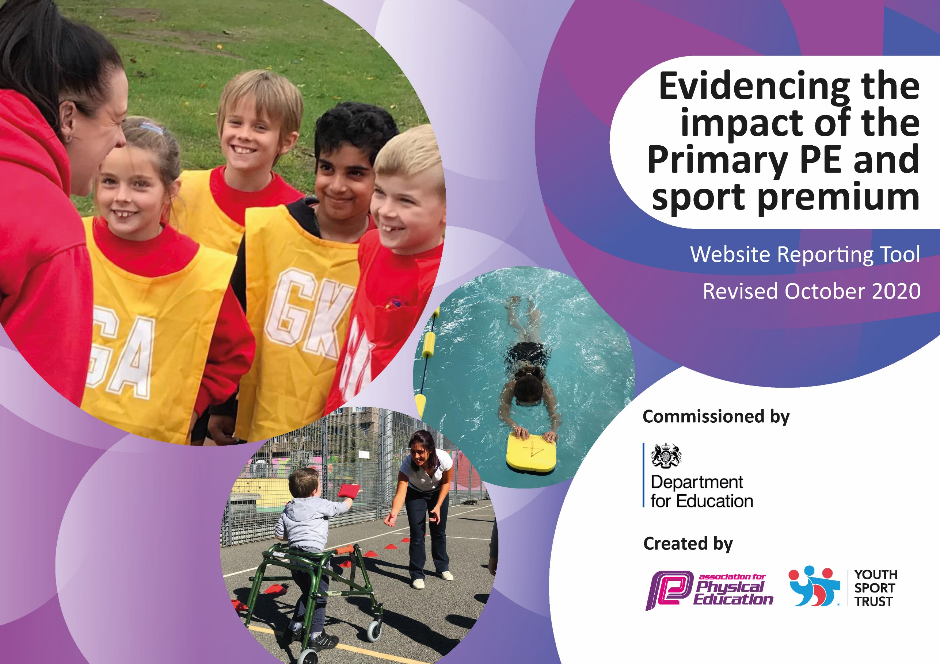

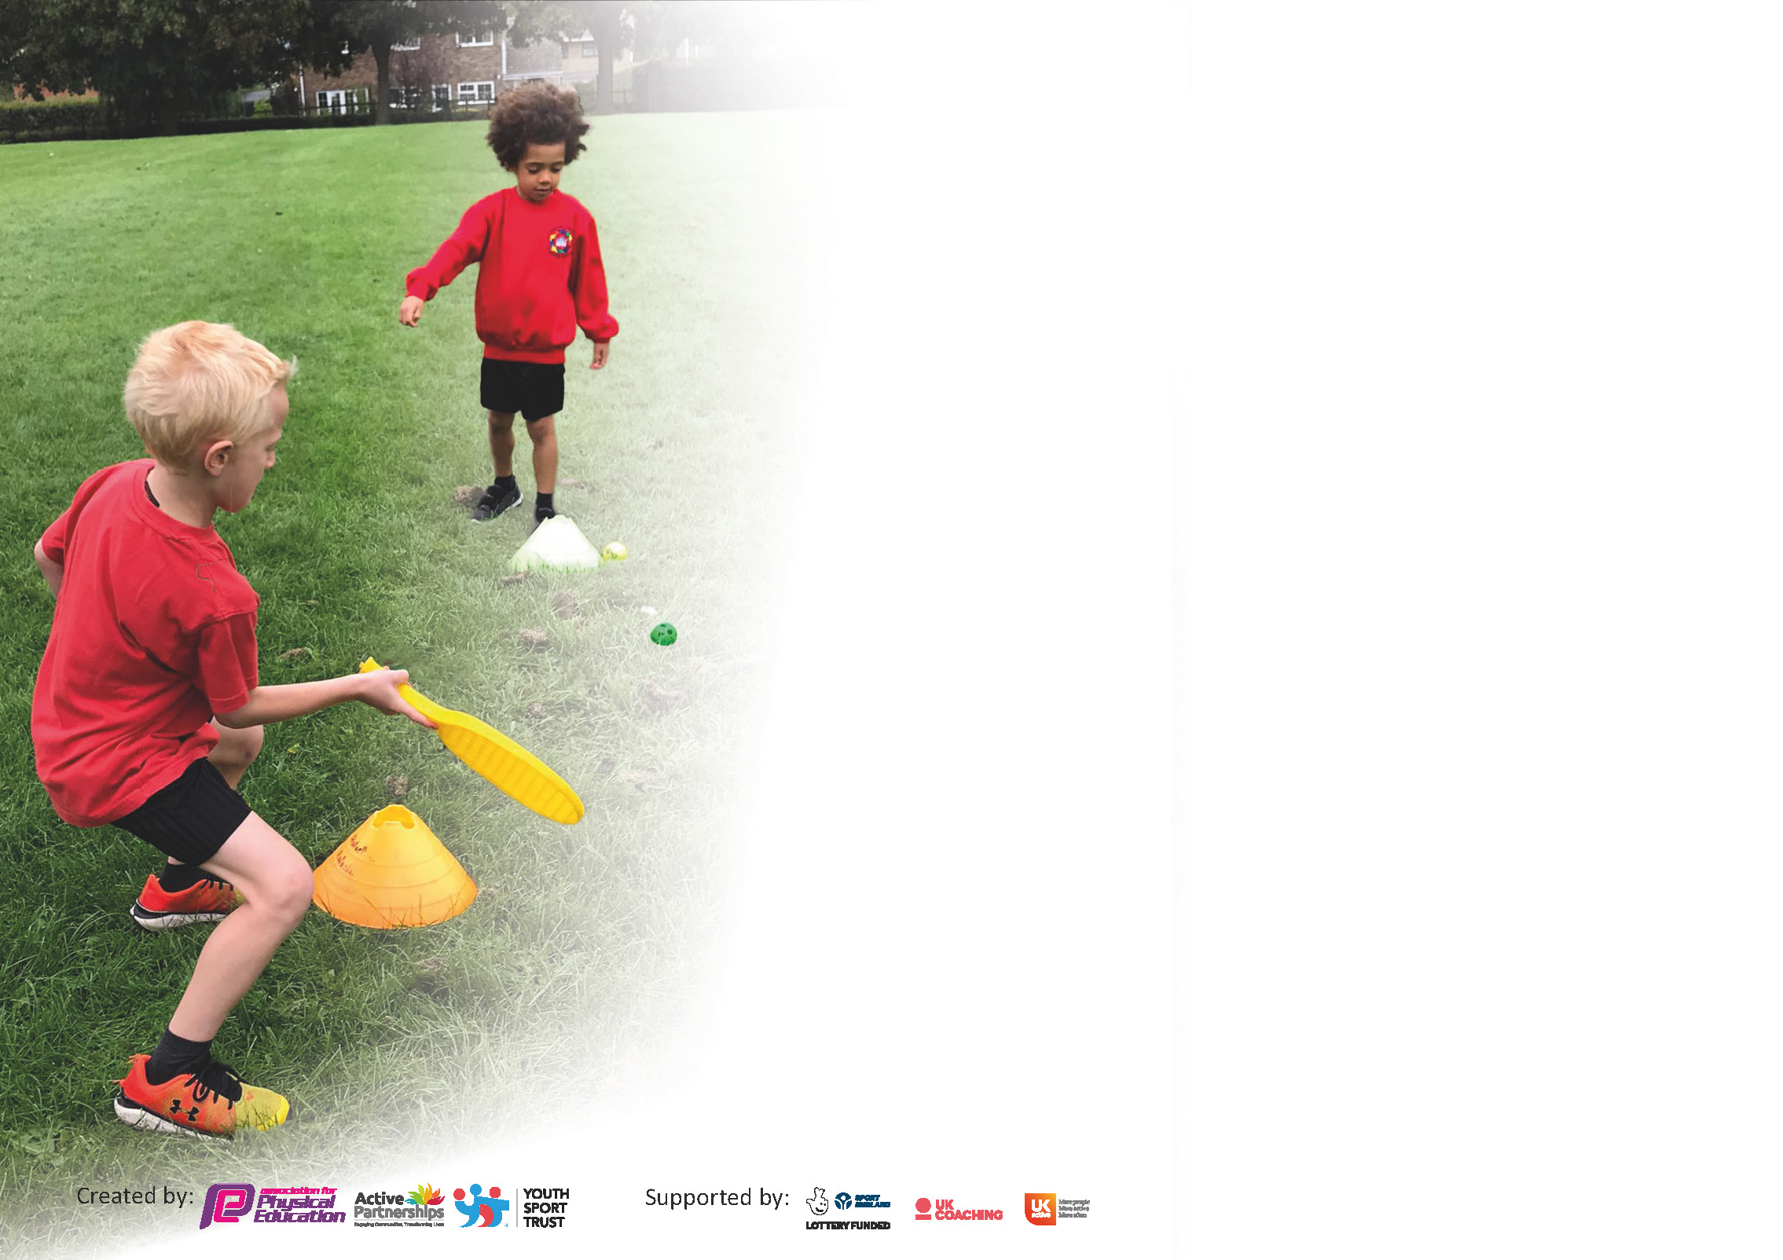

It is important that your grant is used effectively and based on school need. The Education Inspection Framework (Ofsted 2019 p64) makes clear there will be a focus on **‘whether leaders and those responsible for governors all understand their respective roles and perform these in a way that enhances the effectiveness of the school’**.

Under the Quality of Education criteria (p41) inspectors consider the extent to which schools can articulate their curriculum (INTENT), construct their curriculum (IMPLEMENTATION) and demonstrate the outcomes which result (IMPACT).

To assist schools with common transferable language this template has been developed to utilise the same three headings which should make your plans easily transferable between working documents.

Schools must use the funding to make **additional and sustainable** improvements to the quality of Physical Education, School Sport and Physical Activity (PESSPA) they offer. This means that you should use

the Primary PE and sport premium to:

* Develop or add to the PESSPA activities that your school already offer
* Build capacity and capability within the school to ensure that improvements made now will benefit pupils joining the school in future years

Please visit gov.uk for the revised DfE guidance including the 5 key indicators across which schools should demonstrate an improvement. This document will help you to review your

provision and to report your spend. DfE encourages schools to use this template as an effective way of meeting the reporting requirements of the Primary PE and sport premium.

We recommend you start by reflecting on the impact of current provision and reviewing the previous spend.

Schools are required to publish details of how they spend this funding as well as on the impact it has on pupils’ PE and sport participation and attainment by the end of the summer term or by **31st July 2021** at the latest.

# ** In the case of any under-spend from 2019/20 which has been carried over this must be used and published by 31st March 2021.

We recommend regularly updating the table and publishing it on your website throughout the year. This evidences your ongoing self-evaluation of how you are using the funding to secure maximum, sustainable impact. Final copy must

be posted on your website by the end of the academic year and no later than the 31st July 2021. To see an example of how to complete the table please click HERE.

Created by: Supported by:

Please note: Although there has been considerable disruption in 2020 it is important that you publish details on your website of how you spend the funding - this is a legal requirement.

Support for review and reflection - considering the 5 key indicators from DfE, what development needs are a priority for your setting and your pupils now and why? Use the space below to reflect on previous spend and key achievements and areas for development.

N.B. In this section you should refer to any adjustments you might have made due to Covid-19 and how these will influence further improvement.

|  |  |
| --- | --- |
| Key achievements to date until April 2022 – March 2023: | Areas for further improvement and baseline evidence of need: |
| £1,140 used to provide lunchtime sports clubs which all children benefit from, not just those whose parents sign up for them to attend after school.  £1,500 for village hall hire and cleaning, without which we would not be able to deliver indoor PE during the cold, wet winter months.  £500 for Forest Schools staffing – in the absence of parent volunteers, without additional adult support, Forest Schools would not be able to take place. Also £194 Forest Schools insurance.  £599 Dance workshops and £500 drama workshops – to upskill staff to deliver high-quality cross-curricular literacy lessons with a movement and drama element to enable pupils to become engrossed in character portrayal and to use this for high-quality pieces of extended writing.  £40 dance scarves and gymnastics ribbons to enhance the above and the performance at Snape.  £385 on equipment and inspection of equipment to allow fully equipped lessons and clubs to take place.  £450 School Games Membership fee enabling the school to take part in competitions and tournaments. | The need for a comprehensive scheme of work that non-specialist PE teachers can use in the absence of a specialist sports coach.  More ‘free’ after school clubs as parents seem reluctant to want to pay for these.  Replenish stocks of equipment, ie. Ping pong balls and bats.  Greater opportunities for a variety of sports, eg. Healthy Living / Activities Week |

Did you carry forward an underspend from 202021/22 academic year into the current academic year? **YES**/~~NO~~ * Delete as applicable

# If YES you must complete the following section

**If NO, the following section is not applicable to you**

If any funding from the academic year 2021/22 has been carried over you MUST complete the following section. Any carried over funding MUST be spent by 31 July 2023.

|  |  |  |  |  |
| --- | --- | --- | --- | --- |
| **Academic Year: April 2022 – March 2023** | **Total fund carried over: £16,709 + £1502 (b/f) - £5,308 spend = £12,903** | **Date Updated: April 2023** |  | |
| What Key indicator(s) are you going to focus on? 1, 2, 3 & 4 | | | | Total Carry Over Funding: |
| £12,903 |
| **Intent** | **Implementation** | | **Impact** |  |
| Your school focus should be clear how you want to impact on your pupils. | Make sure your actions to achieve are linked to your intentions: | Carry over funding allocated: | Evidence of impact: How can you measure the impact on your pupils; you may have focussed on the difference that PE, SS & PA have made to pupils re-engagement with school. What has changed?: | Sustainability and suggested next steps and how does this link with the key indicators on which you are focussing this academic year?: |
| 1 - Provision of after school clubs to enable pupils to take part in competitive opportunities in both intra and inter school events.  1 - Employment of a lunchtime sports coach (at least 2 lunchtimes per week) to supervise, encourage and enhance physical activity at lunchtime  1 - To provide playground equipment for pupils, based on feedback, suitable to enable pupils to stay active.  1 - Additional cost of playground / field markings  1 - Bikes and scooters purchased for EYFS/KS1 playtimes  1 - Monkey bars purchased to enable pupils to keep active at playtimes  1 - Investigate the purchasing of a Ball Wall to enable pupils to develop ball skills  2 – Raise the profile of sport through more staff training for whole school improvement,, eg. build on the dance and drama training in the Autumn 2022.  3 - Purchasing of either Complete PE or GetSet4PE to provide staff with the tools to deliver high quality PE lessons  3 - Ensure the school has a range of equipment, in the correct sizes, and in good condition is available for use in PE lessons (as per the new SoW), sports clubs and additional sporting opportunities.  4 - To provide a broader range of experiences to pupils throughout Healthy Living / Activity Week  4 - Forest Schools offered to all pupils during the school day and as an after-school opportunity. | Netball club, girls football, athletics and skiing clubs will run over the summer term.  Other clubs will run in the Autumn and Spring terms determined by which competitions the school is entering.  The employment of a lunchtime sports coach has inspired and enabled to be active, taught new skills, helped pupils to regulate games and to use equipment correctly and sensibly.  Gain pupil perceptions decide which equipment should be purchased for use on the playground a play and lunch times. Equipment that has been well-used and worn also replaced.  Playground markings, including netball court and football pitch / race track  A section of the playground to be allocated as a cycle track to develop the gross motor skills  Monkey bars installed to build upper body strength  Installation of a ball wall  Training through School Games membership and training bespoke to the school.  Purchase a scheme of work and enjoy the benefits it offers.  Ongoing review to identify and purchase any equipment which needs updating or replacing.  Pupils to take part in a broader range of activities than they would normally:-  Additional staffing costs and resources | £400 summer term carried over from 22/23  £300 summer term carried over from 22/23  £600 summer term carried over from 22/23  £300  £2000 summer term carried over from 22/23  £1000 summer term carried over from 22/23  £2500 summer term carried over from 22/23  £1000 summer term carried over from 22/23  £350 carried over from 22/23  £1500 summer term carried over from 22/23  Karate £350  Skateboarding £300  Climbing wall/tobogganing £400  Sailing £300  Skiing £250  Beach Schools £650  All carried over from 22/23  £703 carried over from 22/23 |  |  |

|  |  |
| --- | --- |
| Meeting national curriculum requirements for swimming and water safety.  N.B Complete this section to your best ability. For example you might have practised safe self-rescue techniques on dry land. |  |
| What percentage of your current Year 6 cohort swim competently, confidently and proficiently over a distance of at least 25 metres?  **N.B.** Even though your pupils may swim in another year please report on their attainment on leaving primary school at the end of the summer term.  **Current Year 5s who will not swim again in Year 6** | 100%  **93.33%** |
| What percentage of your current Year 6 cohort use a range of strokes effectively [for example, front crawl, backstroke and breaststroke]?  **Current Year 5s who will not swim again in Year 6** | 100%  **86.66%** |
| What percentage of your current Year 6 cohort perform safe self-rescue in different water-based situations?  **Current Year 5s who will not swim again in Year 6** | 71.4%  **86.66%** |
| Schools can choose to use the Primary PE and sport premium to provide additional provision for swimming but this must be for activity **over and above** the national curriculum requirements. Have you used it in this way? | Not since the Autumn/Spring of 2021/22 when we purchased an extra term of swimming to make up for those lessons lost during lockdowns. In Spring 2023 just years 3 – 5 participated in swimming lessons. |

**Action Plan and Budget Tracking**

Capture your intended annual spend against the 5 key indicators. Clarify the success criteria and evidence of impact that you intend to measure to evaluate for pupils today and for the future.

|  |  |  |  |  |
| --- | --- | --- | --- | --- |
| **Academic Year:** 2023/24 | **Total fund allocated:** £9,450 | **Date Updated:** | |  |
| **Key indicator 1:** The engagement of all pupils in regular physical activity – Chief Medical Officers guidelines recommend that primary school pupils undertake at least 30 minutes of physical activity a day in school | | | | Percentage of total allocation: |
| 31.9% |
| **Intent** | **Implementation** | | **Impact** | £9,450 |
| Your school focus should be clear what you want the pupils to know and be able to do and about  what they need to learn and to  consolidate through practice: | Make sure your actions to achieve are linked to your intentions: | Funding allocated: | Evidence of impact: what do pupils now know and what can they now do? What has changed?: | Sustainability and suggested next steps: |
| Provision of after school clubs to enable pupils to take part in competitive opportunities in both intra and inter school events.  Employment of a lunchtime sports coach (at least 2 lunchtimes per week) to supervise, encourage and enhance physical activity at lunchtime  To provide playground equipment for pupils, based on feedback, suitable to enable pupils to stay active, eg. replace ping pong balls.  Additional cost of playground / field markings  Bikes and scooters purchased for EYFS/KS1 playtimes  Monkey bars purchased to enable pupils to keep active at playtimes  Membership of the School Games to enable pupils to participate in a range of competitions, training for staff, etc.  Investigate the purchasing of a Ball Wall to enable pupils to develop ball skills | Netball club, girls football, athletics and skiing clubs will run over the summer term.  Other clubs will run in the Autumn and Spring terms determined by which competitions the school is entering.  The employment of a lunchtime sports coach has inspired and enabled to be active, taught new skills, helped pupils to regulate games and to use equipment correctly and sensibly.  Gain pupil perceptions decide which equipment should be purchased for use on the playground a play and lunch times. Equipment that has been well-used and worn also replaced.  Playground markings, including netball court and football pitch / race track  A section of the playground to be allocated as a cycle track to develop the gross motor skills  Monkey bars installed to build upper body strength  Participation in a variety of competitions and tournaments.  Installation of a ball wall | £400 summer term carried over from 22/23  £800 Autumn and Spring terms  £300 summer term carried over from 22/23  £600 Autumn and Spring terms  £600 summer term carried over from 22/23  £400 allocated for Autumn/Spring  £300  £2000 summer term carried over from 22/23  £1000 summer term carried over from 22/23  £550  £2500 summer term carried over from 22/23 |  |  |
| **Key indicator 2:** The profile of PESSPA being raised across the school as a tool for whole school improvement | | | | Percentage of total allocation: |
| 3.37% |
| **Intent** | **Implementation** | | **Impact** | £1,000 |
| Your school focus should be clear what you want the pupils to know and be able to do and about  what they need to learn and to  consolidate through practice: | Make sure your actions to achieve are linked to your intentions: | Funding allocated: | Evidence of impact: what do pupils now know and what can they now do? What has changed?: | Sustainability and suggested next steps: |
| Raise the profile of sport through more staff training to improve the confidence, knowledge and skills of all staff, for whole school improvement,, eg. build on the dance and drama training in the Autumn 2022. | Training through School Games membership and training bespoke to the school. | £1,000 summer term carried over from 22/23 |  |  |

|  |  |  |  |  |
| --- | --- | --- | --- | --- |
| **Key indicator 3:** Increased confidence, knowledge and skills of all staff in teaching PE and sport | | | | Percentage of total allocation: |
| 10.13% |
| **Intent** | **Implementation** | | **Impact** | £3,000 |
| Your school focus should be clear | Make sure your actions to | Funding | Evidence of impact: what do | Sustainability and suggested |
| what you want the pupils to know | achieve are linked to your | allocated: | pupils now know and what | next steps: |
| and be able to do and about | intentions: |  | can they now do? What has |  |
| what they need to learn and to |  |  | changed?: |  |
| consolidate through practice: |  |  |  |  |
| Membership of the School Games and training  Purchasing of either Complete PE or GetSet4PE to provide staff with the tools to deliver high quality PE lessons  Ensure the school has a range of equipment, in the correct sizes, and in good condition is available for use in PE lessons (as per the new SoW), sports clubs and additional sporting opportunities. | As above  Purchase a scheme of work and enjoy the benefits it offers.  Ongoing review to identify and purchase any equipment which needs updating or replacing. | As above  £1000 carried over from 22/23  £1000 summer term carried over from 22/23  £1000 Autumn / Spring terms |  |  |
| **Key indicator 4:** Broader experience of a range of sports and activities offered to all pupils | | | | Percentage of total allocation: |
| 48.88% |
| **Intent** | **Implementation** | | **Impact** | £8,553 |
| Your school focus should be clear | Make sure your actions to | Funding | Evidence of impact: what do | Sustainability and suggested |
| what you want the pupils to know | achieve are linked to your | allocated: | pupils now know and what | next steps: |
| and be able to do and about | intentions: |  | can they now do? What has |  |
| what they need to learn and to |  |  | changed?: |  |
| consolidate through practice: |  |  |  |  |
| African dance workshop (or similar) to celebrate Black History month  To provide a broader range of experiences to pupils throughout Healthy Living / Activity Week  To provide a broader range of experiences to all pupils  Bikeability to ensure pupils are able to cycle safely  Forest Schools offered to all pupils during the school day and as an after-school opportunity. | As part of Black History Month – children to be provided with an opportunity to develop their dance skills and knowledge of a dance style from a different culture – pupils understanding of the link between dance and culture will be broadened.  Pupils to take part in a broader range of activities than they would normally:-  Whole School trip to Go Ape, Thetford  Year 5 pupils to take part in Bikeability in November 2023  Additional staffing costs and resources. | £600 carried over from 22/23  Karate £350  Skateboarding £300  Climbing wall/tobogganing £400  Sailing £300  Skiing £250  Beach Schools £650 + £**2000** minibus costs to transport children  All carried over from 22/23  £2000  £1000  £703 carried over from 22/23 |  |  |

|  |  |  |  |  |
| --- | --- | --- | --- | --- |
| **Key indicator 5:** Increased participation in competitive sport | | | | Percentage of total allocation: |
| 0% |
| **Intent** | **Implementation** | | **Impact** | £0 |
| Your school focus should be clear | Make sure your actions to | Funding | Evidence of impact: what do | Sustainability and suggested |
| what you want the pupils to know | achieve are linked to your | allocated: | pupils now know and what | next steps: |
| and be able to do and about | intentions: |  | can they now do? What has |  |
| what they need to learn and to |  |  | changed?: |  |
| consolidate through practice: |  |  |  |  |
| Membership of the School Games  Provision of after school clubs to enable pupils to take part in competitive opportunities in both intra and inter school events.  Employment of a lunchtime sports coach (at least 2 lunchtimes per week) to supervise, encourage and enhance physical activity at lunchtime | As above  Netball club, girls football, athletics and skiing clubs will run over the summer term.  Other clubs will run in the Autumn and Spring terms determined by which competitions the school is entering.  The employment of a lunchtime sports coach has inspired and enabled to be active, taught new skills, helped pupils to regulate games and to use equipment correctly and sensibly | As above  As above  As above |  |  |

74.28% allocated – 25.72 in reserve for equipment repairs, purchases, unforeseen circumstances.

|  |  |
| --- | --- |
| Signed off by | |
| Head Teacher: |  |
| Date: | 17.04.23 |
| Subject Leader: |  |
| Date: | 17.04.23 |
| Governor: |  |
| Date: |  |